CSS GENDER STUDIES
T2KB
The Knowledge Base
Topic 2 · Feminist Theories and Practice — every school of feminism, taught from zero
WHAT THIS DOCUMENT GIVES YOU
◆ Syllabus Head III taught from zero in simple English — what feminism is, and every school explained with its thinkers, ideas, strengths and weaknesses
◆ Liberal, radical, Marxist and socialist, psychoanalytic, men's and postmodern feminism — plus intersectionality, Black, postcolonial, eco- and Muslim feminism
◆ A master comparison of the schools, and a reasoned answer to "which feminism suits Pakistan?"
◆ Evidence inside every point, diagrams, today's debates, the examiner's record and five likely questions
◆ About 120 MCQ-style one-liners, every past MCQ on the topic, and a detailed revision sheet for exam night
Federal Public Service Commission · CSS Competitive Examination · Optional paper, 100 marks
Written for CE-2027 onwards · Record: CE-2016 to CE-2026 · Facts current to September 2026

Contents
HOW TO BUILD THE CONTENTS
The contents list below fills itself in. When Word asks "This document contains fields that may refer to other files. Update the fields?", click Yes.
If it does not ask: right-click the grey contents area → Update Field → Update entire table → OK. On a Mac, Control-click the same area. Or press Ctrl + A, then F9 (Windows), to update every field at once. Repeat after any edit, before you export to PDF.

Right-click here and choose Update Field to build the contents.

How to Use This Document

What this topic covers
Topic 2 is syllabus Head III — Feminist Theories and Practice. The syllabus lists seven lines: what is feminism, and six schools — liberal, radical, Marxist/socialist, psychoanalytic, men's and postmodern feminism.
The examiner has also asked about something the syllabus does not name: intersectionality — how gender overlaps with class, race, religion and other identities (2025, and applied to Pakistan in 2026). The recent MCQs are full of newer ideas too — standpoint theory, strategic essentialism, kyriarchy, the matrix of domination, the patriarchal bargain. So this document also teaches Black, postcolonial, eco- and Muslim feminism.
In the descriptive paper Topic 2 is the lightest topic: 7 visits in eleven papers. But it is the second-richest source of MCQs (26 of 140), and its theories are used inside every other topic. When you explain honour killing (Topic 7), quotas (Topic 6) or development (Topic 4), you will reach for a school of feminism from this document.

How this document is built
1. Part Zero gives you the words of the topic, the family tree of feminism, and the four questions every school answers.
2. Part One has nine chapters: one on what feminism is, one on each of the six syllabus schools, one on the newer feminisms, and one comparing them all and asking which suits Pakistan.
3. Part Two sets out today's debates.
4. Part Three lists every past question, what the record shows, and five likely questions.
5. Part Four is a bank of about 120 numbered one-liners in the style of the past MCQs, followed by every past MCQ on the topic.
6. Part Five is the revision sheet — the whole topic in a few pages, every word explained, for the night before the exam.
IN SIMPLE WORDS
Every school of feminism agrees that women are disadvantaged. They disagree about why, where the problem lies, and what to do about it. Learn each school by its answers to those questions and you will never mix them up.

Part Zero — The ABC of Topic 2

0.1 The words of this topic
Table 1 · The key terms of Topic 2 (★ = you must be able to define it in one sentence).
Term | Simple meaning, with an example
Feminism ★ | The belief that women and men should have equal rights and chances, and the movement to achieve it.
Patriarchy ★ | A system in which men hold most power and this is treated as natural.
Sexism | Unfair treatment or prejudice because of a person's sex. Paying a woman less for the same job.
Liberal feminism ★ | Equality through equal rights, laws, education and opportunity within the existing system.
Radical feminism ★ | Patriarchy is the deepest root of women's oppression; society must be changed at the root.
Marxist feminism ★ | Women's oppression comes from capitalism and private property.
Socialist feminism ★ | Capitalism and patriarchy together oppress women — the "dual systems" view.
Psychoanalytic feminism ★ | Women's oppression is rooted in early childhood and the unconscious mind.
Men's feminism ★ | Men who support feminist goals and study how patriarchy shapes men.
Postmodern feminism ★ | There is no single "woman" and no single truth; identities are made in language.
Post-structural feminism | Close to postmodern: identities are unstable and made through discourse (MCQ 2018, 2023).
Intersectionality ★ | Gender overlaps with race, class, religion and other identities to create unique disadvantage (Crenshaw, 1989).
Black feminism | Feminism centred on Black women facing race, class and gender together.
Postcolonial feminism | Criticises Western feminism for speaking for "Third World women".
Ecofeminism | Links the domination of women with the domination of nature.
Muslim / Islamic feminism | Gender justice through re-reading Islamic sources.
Standpoint theory ★ | Knowledge depends on social position; the oppressed can see what the powerful miss.
Consciousness-raising | Small groups where women shared experiences and saw them as political, not personal.
"The personal is political" ★ | Private life — marriage, housework, sex — is shaped by power too.
Domestic labour | Unpaid housework and care; a key subject of Marxist and socialist feminism.
Dual-systems theory | Socialist view that capitalism and patriarchy are two linked systems.
Penis envy / womb envy | Freud's claim that girls envy the penis; Horney's reply that men envy women's power to give birth.
Écriture féminine | "Women's writing" from the female body and experience (Hélène Cixous).
Gynocriticism | The study of women writers (Elaine Showalter; MCQ 2024).
Strategic essentialism | Temporary unity around an identity to win political goals (Spivak; MCQ 2026).
Matrix of domination | How overlapping oppressions are organised across society (Patricia Hill Collins; MCQ 2026).
Kyriarchy | Interlocking systems of domination — gender, race, class, empire (Schüssler Fiorenza; MCQ 2026).
Patriarchal bargain | The strategies women use to secure what they can within patriarchy (Kandiyoti; MCQ 2026).
Misogyny | Hatred of, or contempt for, women.

0.2 The family tree of feminism
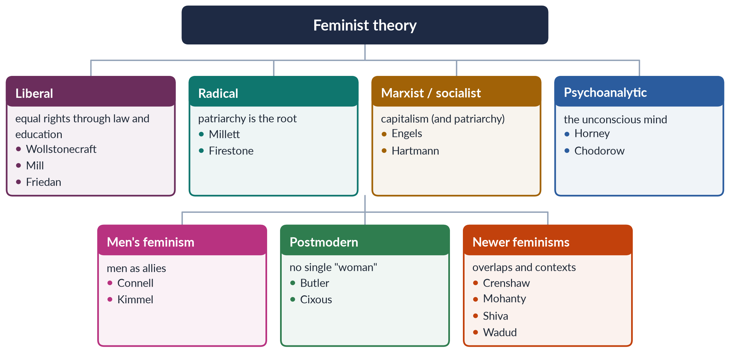
Figure 1 · The family tree of feminist theory: the six syllabus schools and the newer feminisms.

0.3 The four questions every school answers
The easiest way to keep the schools apart is to ask each of them the same four questions.
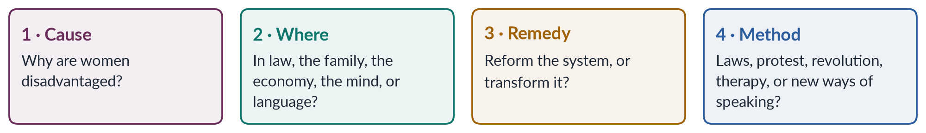
Figure 2 · The four questions that separate the schools of feminism.
Table 2 · The six syllabus schools on one page.
School | Main cause of women's oppression | Where it happens | Remedy
Liberal | Unequal laws and opportunities | Public life: law, education, work | Reform: equal rights, education, laws
Radical | Patriarchy itself | Everywhere, especially family, sexuality, body | Transform society at the root
Marxist | Capitalism and private property | The economy and class | End capitalism
Socialist | Capitalism and patriarchy together | Economy and family | Fight both systems
Psychoanalytic | Early childhood and the unconscious | The mind and family | Change childcare; re-read Freud
Men's | Patriarchy harms men too | Masculinities | Men as allies; change manhood
Postmodern | Fixed categories and language | Discourse and identity | Question all categories

EXAMINER'S EYE · HOW THE EXAMINER USES THIS TOPIC
The examiner rarely asks you to list the schools. He or she asks you to compare them ("How is radical feminism different from socialist feminism?", 2016), to explain one in depth (Marxist/socialist, 2021; psychoanalytic, 2021), to apply them to Pakistan ("Which type(s) of feminism can elevate the status of women in Pakistan?", 2018), or to write short notes (postmodern, 2019; radical, 2024). Learn each school so that you can (1) define it, (2) name its thinkers and books, (3) state its cause, place and remedy, (4) give its strengths and weaknesses, and (5) apply it to Pakistan.

Part One — The Schools of Feminism

Chapter 1 · What Is Feminism?
Before you can compare the schools of feminism, you need to know what they share. This chapter defines feminism, traces the word, clears away the common myths, and shows that feminism has South Asian and Muslim roots as well as Western ones. It answers the first half of the 2016 question: "What is feminism?"

1.1 Feminism in one sentence
In the simplest words, feminism is the belief that women and men should have equal rights, equal dignity and equal chances in life, together with the action taken to make that belief real.
So feminism has two parts:
1. An idea (a theory). Women as a group are disadvantaged — in law, work, family, politics and culture — and this disadvantage is made by society, not fixed by nature. (Topic 1 taught you the sex/gender distinction on which this rests.)
2. A practice (a movement). People organise to change that situation — through writing, campaigns, protests, lawsuits, votes, laws and new ways of living.
That is why the syllabus head is called "Feminist Theories and Practice". A school of feminism is always both: a way of explaining women's position and a plan for changing it.
✦ DEFINITION
Feminism · the South Asian definition to quote in Pakistan
"An awareness of women's oppression and exploitation in society, at work and within the family, and conscious action by women and men to change this situation."
➜ Kamla Bhasin and Nighat Said Khan, Some Questions on Feminism and its Relevance in South Asia (1986). Nighat Said Khan is a Pakistani feminist scholar. Note two features: it names three sites (society, work, family) and it includes men.

✦ DEFINITION
Feminism · the shortest definition
"Simply put, feminism is a movement to end sexism, sexist exploitation, and oppression."
➜ bell hooks, Feminism Is for Everybody (2000). hooks spelt her name in small letters. The definition targets sexism, not men — so men can be feminists too, and women can be sexist.

1.2 Three older definitions worth knowing
- Rebecca West (British writer, 1913) joked: "I myself have never been able to find out precisely what feminism is: I only know that people call me a feminist whenever I express sentiments that differentiate me from a doormat or a prostitute." The point: "feminist" was already used as an insult for any woman who refused to be treated as an object.
- Dictionaries define feminism as the advocacy of women's rights on the basis of the equality of the sexes.
- Academic writers stress that feminism is a perspective: it puts gender at the centre of the analysis of society. A 2025 MCQ asked why feminist perspectives are distinctive; the answer was that they emphasise the centrality of gender.
IN SIMPLE WORDS
A sociologist might study poverty by looking at class. A feminist asks an extra question: "How are women and men affected differently — and why?" That extra question, asked about everything, is the feminist perspective.

1.3 Where the word came from
- The word began in France as féminisme. The French women's-rights campaigner Hubertine Auclert used "feminist" for herself and her cause in 1882, in her journal La Citoyenne. (Many books credit the philosopher Charles Fourier with inventing the word earlier, but this claim is not firmly proved.)
- The word reached English in the 1890s.
- The ideas are much older than the word. Writers in many cultures argued for women's education and dignity long before anyone called it "feminism".
TRAP · FEMINISM DID NOT BEGIN IN 1960S AMERICA
Many candidates write as if feminism was invented by American women in the 1960s. The ideas go back centuries; the word is French and dates from the 1880s; organised movements began in the 1800s (Seneca Falls, 1848). And South Asia had its own early feminist writers (§1.6).

1.4 The waves of feminism in brief
Historians often divide Western feminism into waves. The metaphor was made popular by the journalist Martha Weinman Lear in 1968, who wrote of "the second feminist wave". The waves are taught in full in Topic 3 (feminist movements). Here you need only the outline, because each school belongs mainly to one wave.
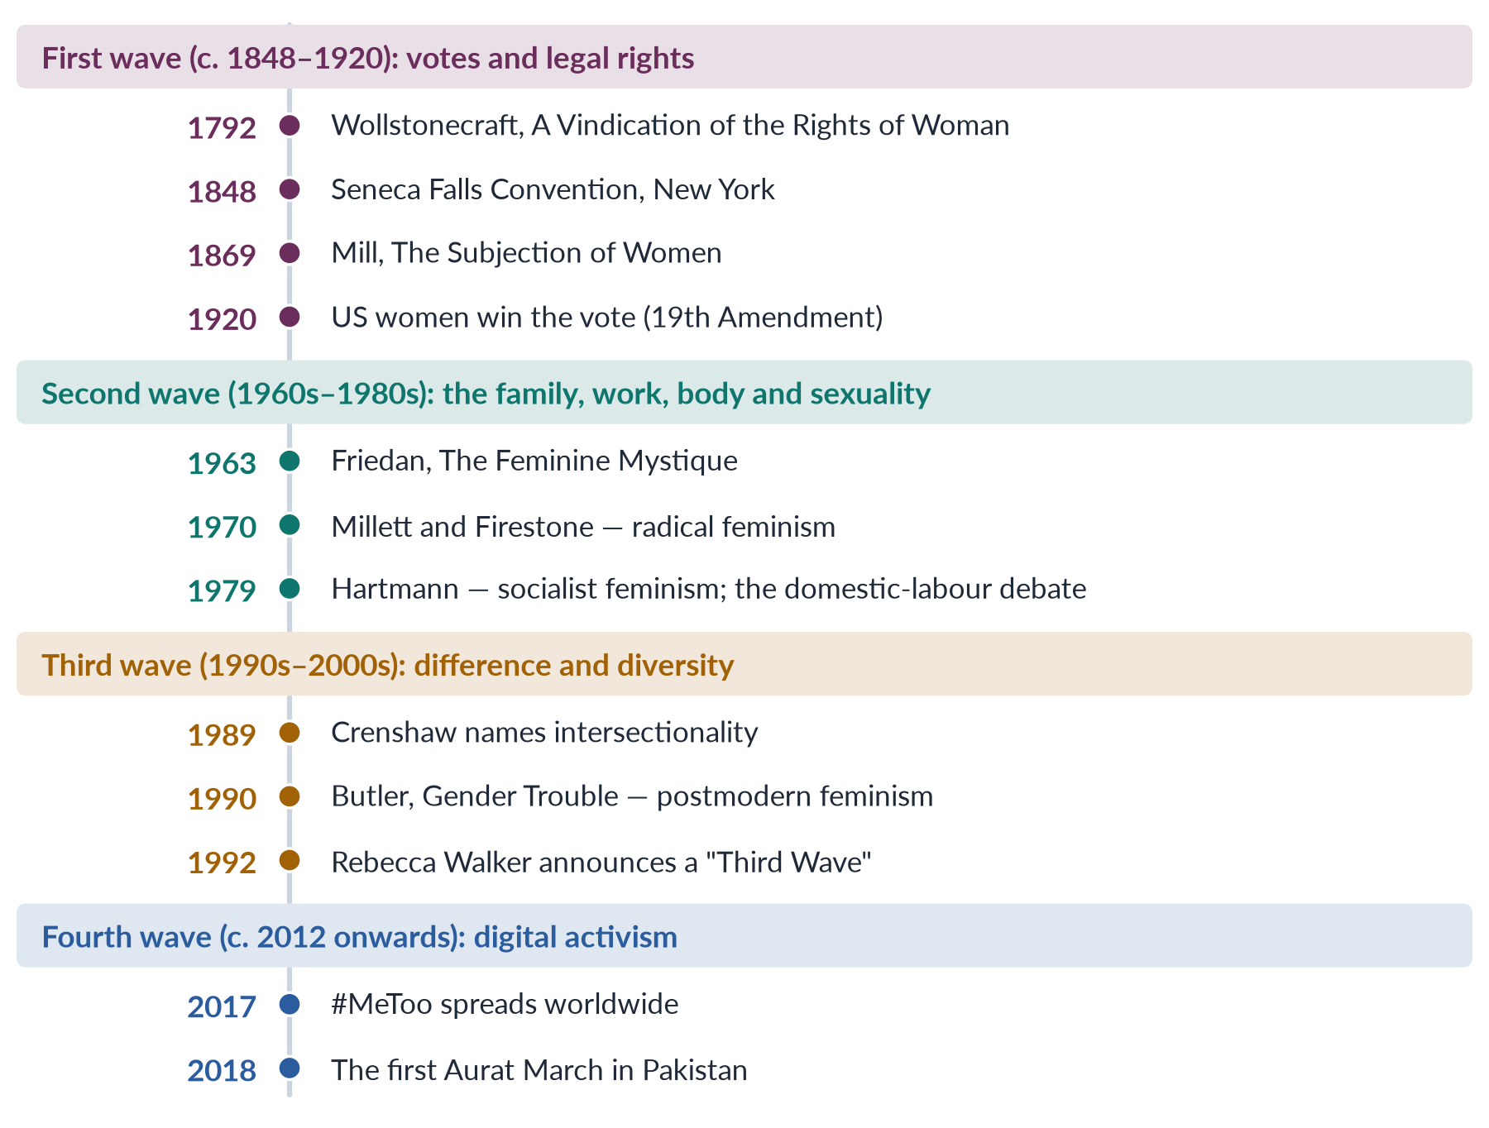
Figure 3 · The four waves of Western feminism, and the schools that belong to each.
Table 3 · Which schools belong mainly to which wave.
Wave | Main demands | Schools most associated with it
First | Vote, property, education, legal equality | Liberal feminism; early Marxist feminism
Second | Equal pay, reproductive rights, violence, sexuality, housework | Radical, socialist, psychoanalytic, second-wave liberal
Third | Diversity among women; identity; culture | Postmodern, Black, postcolonial, intersectional
Fourth | Online campaigns against harassment and violence | Draws on all, especially intersectionality

NOTE
The wave picture is a simplification. Critics point out that it follows white, Western history, and that it hides activism between the "waves". Use it as a map, not a law.

1.5 The common ground: what all feminists share
The schools disagree about many things, but all accept five basic claims.
1. Women are disadvantaged as a group — in power, money, safety, voice and freedom.
2. This is not natural. It is produced by society and can be changed.
3. The personal and the political are linked. Laws, customs and ideas shape even the most private parts of life.
4. Women's experience counts as knowledge. What women know from their lives is valid evidence.
5. Change is possible and worth working for.
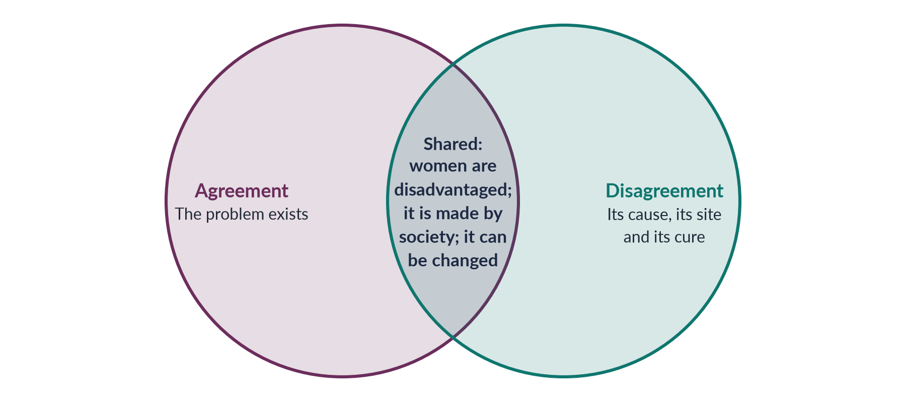
Figure 4 · What every school shares, and where the schools part company.

1.6 Feminism in South Asia and the Muslim world
The idea that feminism is purely Western is common in Pakistan. The history shows otherwise.
- Tarabai Shinde (Maharashtra) wrote Stri Purush Tulana ("A Comparison of Women and Men") in 1882 — an angry attack on the double standards applied to women and men.
- Begum Rokeya Sakhawat Hossain (Bengal) wrote Sultana's Dream in 1905, a story of a "Ladyland" where men are kept in seclusion and women run a peaceful, scientific country. She also founded a girls' school in Calcutta in 1911.
- Sayyid Mumtaz Ali of Lahore wrote Huquq-un-Niswan ("The Rights of Women", 1898), arguing from the Qur'an that Islam gives women rights that Muslim custom had denied.
- In Egypt, Qasim Amin published The Liberation of Women (1899), and Huda Shaarawi founded the Egyptian Feminist Union in 1923.
- In Pakistan, the All Pakistan Women's Association (APWA) was founded by Begum Ra'ana Liaquat Ali Khan in 1949, and the Women's Action Forum (WAF) in 1981. (Their history belongs to Topic 3.)
PAKISTAN ANGLE · THE QUAID ON WOMEN'S PLACE IN THE NATION
Speaking at Aligarh on 10 March 1944, Quaid-e-Azam Muhammad Ali Jinnah said: "No nation can rise to the height of glory unless your women are side by side with you." Pakistani feminists of every school quote this line to show that women's equality belongs to the founding vision of the country, not to a foreign agenda.

1.7 Myths about feminism
Table 4 · Common myths about feminism, and the facts.
Myth | Fact
"Feminism means hating men." | Every definition above targets sexism and oppression, not men. Many feminists are men (Chapter 6).
"Feminism is one ideology." | It is a family of theories that disagree sharply with each other (Chapters 2–8).
"Feminism is Western." | South Asian and Muslim writers argued for women's rights in the 1880s–1900s, and feminism takes local forms (Chapter 8).
"Feminism is against religion." | Some feminists are secular, but Muslim feminists work from the Qur'an (Chapter 8).
"Feminism wants women to be like men." | Some schools want equal treatment; others value women's difference (Chapters 2, 5).
"Women are already equal; feminism is outdated." | Pakistan ranked 143rd of 145 on the Global Gender Gap Report 2026; female labour-force participation was 24.4% (LFS 2024–25).

1.8 How to classify the schools
There are many ways to sort feminist theories. The syllabus follows the classic list found in textbooks such as Rosemarie Tong's Feminist Thought (first edition 1989): liberal, radical, Marxist/socialist, psychoanalytic, and postmodern. A simple way to arrange them is along a line from reform to revolution.
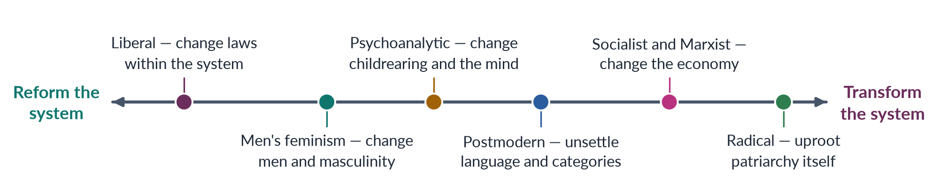
Figure 5 · The schools of feminism from "reform the system" to "transform the system".
EXAMINER'S EYE · ANSWERING "WHAT IS FEMINISM?"
Give (1) a simple definition of your own; (2) one quoted definition — Bhasin and Khan for Pakistan, hooks for brevity; (3) the two parts, theory and practice; (4) the common ground of all schools; (5) a sentence on the word's history and the waves; (6) the South Asian roots; and (7) a line showing that the schools disagree on cause and cure. Then move to whatever the question asks next — in 2016, the difference between radical and socialist feminism (Chapter 9).

Chapter 2 · Liberal Feminism
Liberal feminism is the oldest and most widely accepted school. It says women are held back by unfair laws, customs and lack of opportunity, and that the answer is equal rights within the existing system. A 2023 MCQ asked what "the theory that men and women should be treated equally" is called. The answer: liberal feminism.

2.1 What "liberal" means here
"Liberal" here does not mean "modern" or "Western". It refers to liberalism, the political philosophy of the European Enlightenment (1600s–1700s). Liberalism holds that:
- every individual has reason — the ability to think and choose;
- every individual has natural rights, such as life, liberty and property;
- the state should treat citizens equally and protect their freedom.
Liberal feminists simply ask: if these rights belong to "every individual", why not to women?
✦ DEFINITION
Liberal feminism · the school of equal rights
The view that women are as capable of reason as men, and that their disadvantage comes from legal and customary barriers and unequal opportunities. The remedy is reform: equal rights, equal education, equal access to work and public life.
➜ Key words: individual, reason, rights, equal opportunity, reform, the public sphere.

2.2 The first wave of liberal feminism
✦ THINKER
Mary Wollstonecraft · English writer · *A Vindication of the Rights of Woman* (1792)
Wollstonecraft answered the French thinker Jean-Jacques Rousseau, whose book Émile (1762) said girls should be educated only to please and serve men. She argued that women appear weak and vain because they are denied a rational education. Give girls the same education as boys and they will become rational, virtuous citizens and better mothers.
➜ Often called the founding text of liberal feminism.

- Olympe de Gouges wrote the Declaration of the Rights of Woman and of the Female Citizen (1791) in answer to the French Revolution's Declaration of the Rights of Man. She was executed in 1793.
- At the Seneca Falls Convention (New York, 1848), Elizabeth Cady Stanton and Lucretia Mott presented the Declaration of Sentiments, modelled on the American Declaration of Independence: "We hold these truths to be self-evident: that all men and women are created equal."
✦ THINKER
John Stuart Mill and Harriet Taylor Mill · *The Subjection of Women* (1869)
Mill argued that the legal subordination of women to men is wrong in itself and a hindrance to human progress; it should be replaced by perfect equality. He wrote that "what is now called the nature of women is an eminently artificial thing". His wife Harriet Taylor Mill had earlier written The Enfranchisement of Women (1851), and Mill said she shaped his ideas.
➜ As a member of Parliament, Mill proposed in 1867 that the word "man" in the Reform Bill be replaced by "person", to give women the vote. The proposal failed, but it launched the British suffrage campaign.

The main goals of first-wave liberal feminism were the vote, property rights for married women, access to education and the professions, and equal legal status. New Zealand gave women the national vote in 1893; the United States in 1920; Britain partly in 1918 and fully in 1928.

2.3 The second wave of liberal feminism
✦ THINKER
Betty Friedan · American writer · *The Feminine Mystique* (1963)
Friedan described the unhappiness of educated American housewives in the 1950s — "the problem that has no name". The "feminine mystique" was the belief that women find complete fulfilment in being wives and mothers. Friedan urged women to seek education and careers.
➜ In 1966 she co-founded the National Organization for Women (NOW) and became its first president. The Feminine Mystique appeared in MCQs in both 2024 and 2025.

Second-wave liberal feminists won major legal reforms, especially in the United States:
- the Equal Pay Act (1963);
- Title VII of the Civil Rights Act (1964), banning job discrimination on the basis of sex;
- campaigns for the (never ratified) Equal Rights Amendment;
- the UN Convention on the Elimination of All Forms of Discrimination against Women (CEDAW), adopted in 1979 — in spirit a liberal document of equal rights. Pakistan ratified it in 1996.

2.4 Later liberal feminism
- Susan Moller Okin (Justice, Gender, and the Family, 1989) argued that the family must itself be just. If the family is unequal, children learn injustice at home. This brought liberal ideas into the private sphere.
- Martha Nussbaum (Women and Human Development, 2000) developed the capabilities approach with Amartya Sen: justice means giving each person the real ability to do and be what they value — to be healthy, educated, safe, able to work and take part in politics. This version is widely used in development (Topic 4).
- Zillah Eisenstein (The Radical Future of Liberal Feminism, 1981) argued that the logic of equal rights, followed seriously, leads to deep social change.

2.5 The core ideas in one table
Table 5 · Liberal feminism on the four questions.
Question | Liberal answer
Cause | Unequal laws, customs and opportunities; prejudice and lack of education
Where | The public sphere: law, education, employment, politics
Remedy | Reform, not revolution: equal rights, equal pay, anti-discrimination laws, quotas, education
Method | Lobbying, lawsuits, legislation, elections, public campaigns

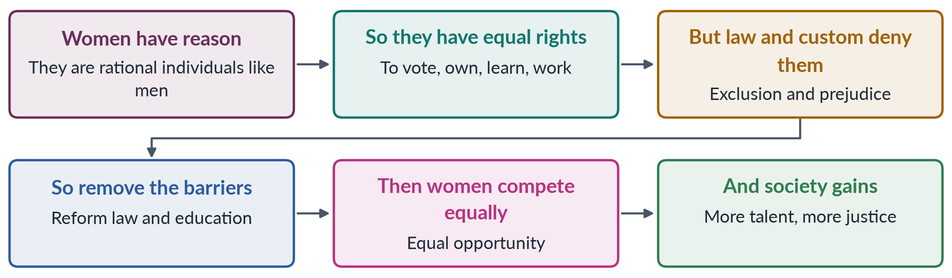
Figure 6 · The liberal feminist chain of reasoning.

2.6 Strengths of liberal feminism
1. Real achievements. The vote, access to universities and professions, equal-pay and anti-discrimination laws — most of the legal gains women enjoy today came from liberal campaigns.
2. Broad acceptance. Its language of rights, fairness and merit persuades people who dislike more radical ideas.
3. Works through institutions. It uses courts, parliaments and constitutions, which makes it practical for policy.
4. Fits international law. CEDAW, the Sustainable Development Goals (Goal 5) and national constitutions speak its language.

2.7 Criticisms of liberal feminism
1. It ignores structures. Equal laws do not produce equal results when women still do most unpaid care. Radical and socialist feminists say it treats the symptoms, not the cause.
2. The public/private divide. Classic liberalism keeps the state out of the family — yet the family is where much inequality happens (housework, domestic violence).
3. Equality as "sameness". It asks women to become like men in a system built around men's lives, rather than changing the system. Difference feminists call this the male norm.
4. Middle-class bias. bell hooks criticised Friedan for writing about educated white housewives while ignoring poor and Black women who were already working.
5. Individualism. It focuses on individual choice and merit, underplaying group disadvantage.
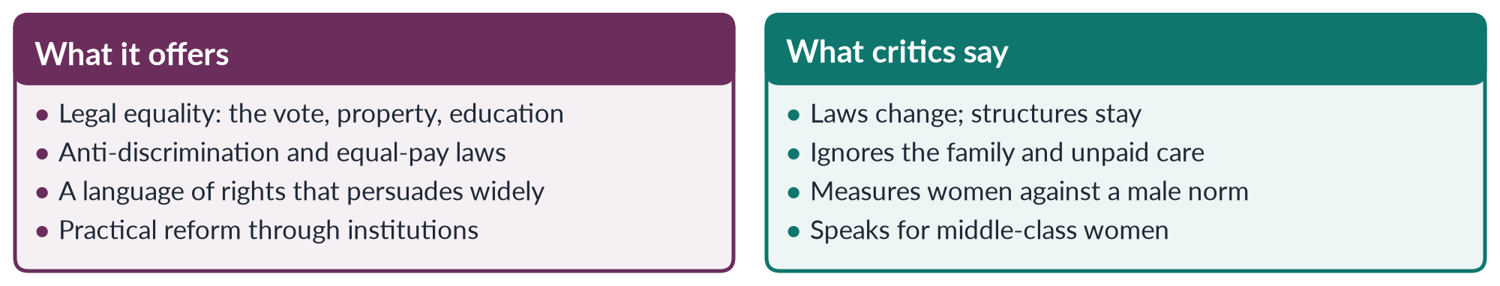
Figure 7 · Liberal feminism: what it offers and what its critics say.

2.8 Liberal feminism in Pakistan
Liberal feminism is the most visible school in Pakistani law and policy, because the Constitution of 1973 speaks its language.
✦ LAW & POLICY
Constitution of Pakistan 1973 · the equality articles
• Article 25: all citizens are equal before law; "there shall be no discrimination on the basis of sex"; the state may make special provision for women and children.
• Article 27: no discrimination in public service on the basis of sex.
• Article 34: steps shall be taken to ensure full participation of women in all spheres of national life.
➜ A liberal-feminist answer on Pakistan always starts from these three articles.

- Legal reforms: the Protection of Women (Criminal Laws Amendment) Act 2006, the Protection against Harassment of Women at the Workplace Act 2010, the honour-killing amendment of 2016, the Anti-Rape (Investigation and Trial) Act 2021, and the Islamabad Child Marriage Restraint Act 2025 (minimum age 18).
- Political quotas: 60 reserved women's seats in the National Assembly (Topic 6).
- Education: campaigns for girls' schooling, symbolised internationally by Malala Yousafzai (Nobel Peace Prize, 2014).
- Institutions: the National Commission on the Status of Women (NCSW, 2000) and provincial women's commissions.
BALANCED VIEW · IS LIBERAL FEMINISM ENOUGH FOR PAKISTAN?
For: it is constitutional, uses the language of rights that Pakistani courts understand, and has won real laws. Against: Pakistan has many good laws that are weakly enforced; poverty, custom and unpaid care keep most women from using their rights. Only 24.4% of working-age women are in the labour force (LFS 2024–25) despite legal equality in employment.
➜ Liberal feminism supplies the legal floor. It needs economic and cultural strategies (Chapters 4 and 9) to turn rights on paper into rights in life.

Chapter 3 · Radical Feminism
"Radical" comes from the Latin radix, meaning root. Radical feminists say that patriarchy is the root of women's oppression — older and deeper than class or law — and that it must be pulled up by the roots, not trimmed by reform. A 2019 MCQ asked what kind of idea "replacing patriarchy" is. The answer: a radical idea. Kate Millett was named as a radical feminist in MCQs of 2016 and 2023, and Firestone's The Dialectic of Sex in 2016. The school was a short note in 2024.

3.1 Where radical feminism came from
Radical feminism was born in the United States in the late 1960s. Many young women were active in the civil-rights movement and the anti-Vietnam War "New Left". They found that the men of these movements, who spoke of freedom and equality, expected women to make the coffee, type the leaflets and stay silent in meetings.
These women concluded that male dominance was a problem of its own, not just a side effect of capitalism or racism. They formed their own groups:
- New York Radical Women (1967), which organised the protest against the Miss America beauty contest in 1968. (The famous "bra-burning" never happened; women threw bras, make-up and high heels into a "freedom trash can".)
- Redstockings (1969), whose manifesto declared: "Women are an oppressed class."
✦ DEFINITION
Radical feminism · the school of the root
The view that patriarchy — the system of male power over women — is the most basic and oldest form of oppression, found in every area of life, above all in the family, sexuality and the body. Because it is everywhere, reforming laws is not enough; society and culture must be transformed at the root.
➜ Key words: patriarchy, sex class, sexual politics, the personal is political, consciousness-raising, bodily autonomy, violence against women.

3.2 "The personal is political"
The most famous slogan of the second wave comes from radical feminism.
✦ THINKER
Carol Hanisch · "The Personal Is Political" (essay written 1969, published 1970)
Hanisch defended consciousness-raising groups, which some men on the Left dismissed as "therapy". She argued that when women share their "personal problems" — about husbands, housework, sex, abortion, appearance — they discover that these are not private failings but political problems shared by all women, with a common cause.
➜ Hanisch said the title was given by the editors of Notes from the Second Year (1970), where the essay appeared.

EXAMPLE
A woman in Lahore feels guilty that she is exhausted after her job and the whole housework of a joint family. In a consciousness-raising group she hears ten other women describe the same "personal" problem. She realises it is not her weakness: it is a social arrangement in which women carry a double burden. The personal has become political.

Consciousness-raising — small groups of women meeting to share experiences — was radical feminism's main method. It turned private complaints into shared political awareness.

3.3 The founding thinkers
✦ THINKER
Kate Millett · *Sexual Politics* (1970)
Millett argued that the relationship between the sexes is political — a relationship of power, in which one group (men) rules another (women). She used the word patriarchy for this system and said it works through the family, religion, education, literature and, in the last resort, force. She showed patriarchy even in "great" novels by men such as D. H. Lawrence and Norman Mailer.
➜ "Sexual politics" means power relations between the sexes. Millett made "patriarchy" the key concept of radical feminism.

✦ THINKER
Shulamith Firestone · *The Dialectic of Sex: The Case for Feminist Revolution* (1970)
Firestone argued that women's oppression began in biology — in the burden of pregnancy, childbirth and nursing, which made women dependent on men. She called women a "sex class" and borrowed Marx's method: just as workers must seize the means of production, women must seize control of reproduction. She even imagined a future where technology (artificial reproduction) would free women from childbearing.
➜ Her ideas were bold and controversial; she stands for radical-libertarian feminism.

Other radical thinkers you should know:
- Robin Morgan edited Sisterhood Is Powerful (1970), an influential collection of radical writings.
- Susan Brownmiller (Against Our Will, 1975) argued that rape is not a rare crime of passion but a tool by which men keep all women in fear.
- Mary Daly (Gyn/Ecology, 1978) exposed practices harmful to women across cultures and called for a women-centred spirituality.
- Adrienne Rich (Of Woman Born, 1976; "Compulsory Heterosexuality and Lesbian Existence", 1980) separated motherhood as an experience from motherhood as an institution controlled by men.
- Catharine MacKinnon (Sexual Harassment of Working Women, 1979) argued that sexual harassment is a form of sex discrimination — an argument later accepted by US courts. With Andrea Dworkin she campaigned against pornography as a violation of women's civil rights (1983).

3.4 Two kinds of radical feminism
Rosemarie Tong's textbook divides radical feminists into two groups, who disagree about sexuality and "femininity".
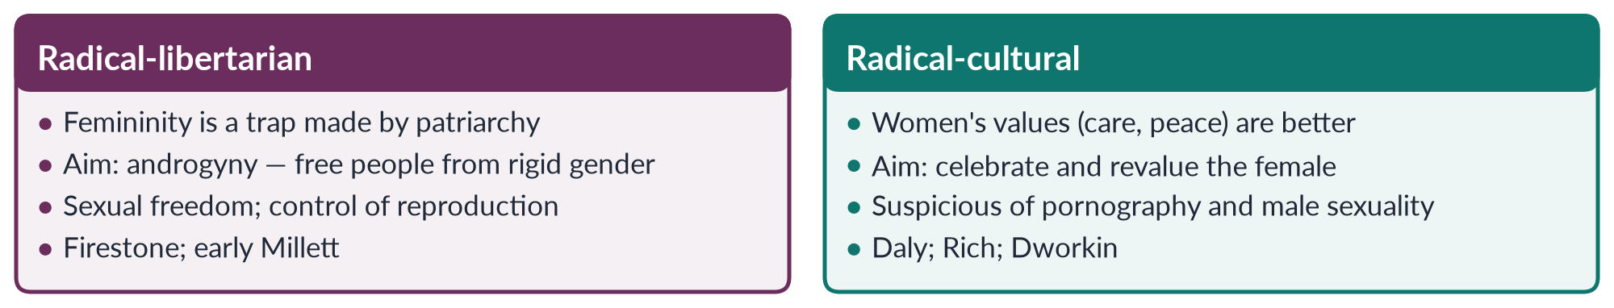
Figure 8 · Radical-libertarian and radical-cultural feminism.

3.5 The core ideas in one table
Table 6 · Radical feminism on the four questions.
Question | Radical answer
Cause | Patriarchy — the oldest, most universal form of oppression; for some, rooted in biology and reproduction
Where | Everywhere, but above all the family, marriage, sexuality, the body and violence
Remedy | Transform society and culture at the root; end male control of women's bodies and sexuality
Method | Consciousness-raising, direct protest, women-only spaces, shelters and rape-crisis centres, campaigns on violence

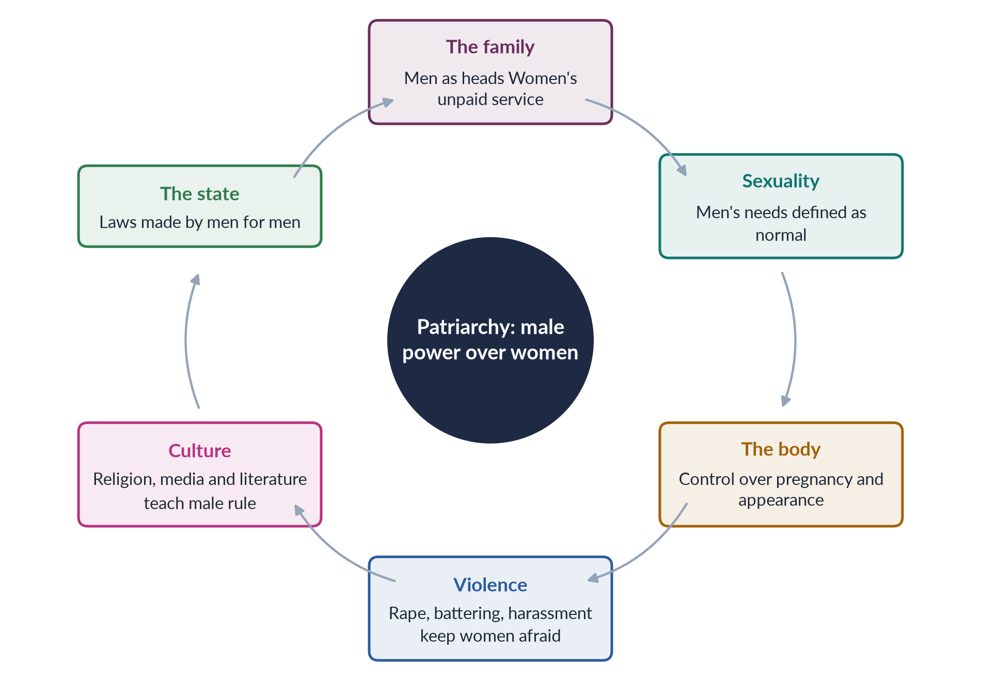
Figure 9 · How patriarchy works in every area of life, according to radical feminists.

3.6 What radical feminism achieved
Radical feminism changed the world's understanding of violence against women more than any other school.
1. Rape crisis centres and women's shelters — the first modern shelter for battered women opened in Chiswick, London, in 1971.
2. Domestic violence was redefined from a "private family matter" into a crime and a public issue.
3. Sexual harassment became a legal wrong (MacKinnon, 1979).
4. Marital rape was gradually recognised as a crime in many countries.
5. Bodily autonomy — women's right to decide about their own bodies — became a central demand.
6. The slogan "the personal is political" entered every later school.
PAKISTAN ANGLE · RADICAL INSIGHTS IN PAKISTANI LAWS AND ACTIVISM
• The Women's Action Forum (1981) fought the Hudood Ordinances (1979), which treated rape victims unable to prove rape as possible adulteresses — a radical-feminist concern with state control of women's bodies.
• Laws on harassment (2010), acid crime (2011), honour killing (2016) and rape (2021) all treat violence against women as a public crime, not a private matter.
• The Aurat March (first held on 8 March 2018) used the slogan Mera Jism Meri Marzi ("My body, my choice") — a direct echo of radical feminism's demand for bodily autonomy. The slogan provoked fierce controversy in 2019–2020.

3.7 Criticisms of radical feminism
1. "Women" treated as one group. By saying all women share one oppression, radical feminism ignored differences of race, class and nation. bell hooks and Audre Lorde argued that it spoke for white, middle-class women.
2. Biological determinism. Firestone's claim that oppression begins in biology risks the same essentialism feminists usually reject.
3. Anti-men image. Some separatist writing gave critics the chance to call all feminism "man-hating", which hurt the movement's appeal.
4. Patriarchy as too universal. If patriarchy is everywhere and always, how does it change? Historians and socialist feminists said it takes different forms in different times and economies.
5. Division over sexuality. The "sex wars" of the 1980s split feminists over pornography and sex work.
6. Culture clash. In societies such as Pakistan, its language on sexuality and the body provokes strong backlash and can be used to discredit the whole women's movement.
BALANCED VIEW · RADICAL FEMINISM IN A CONSERVATIVE SOCIETY
Radical feminism's analysis of violence and control of women's bodies is powerful and has saved lives through shelters and laws. Its slogans and style can alienate the very people whose support is needed. In Pakistan, the most effective campaigns — such as the honour-killing and anti-rape laws — took radical concerns and argued them in the language of the Constitution and of Islam's protection of human dignity.

EXAMINER'S EYE · SHORT NOTE ON RADICAL FEMINISM (2024)
Define it (root; patriarchy). Origin (late 1960s, New Left). Three thinkers with books and dates (Millett, Firestone, Hanisch). Two or three core ideas (patriarchy, personal is political, sex class, bodily autonomy). Two achievements (shelters, harassment law). Two criticisms (ignores race and class; essentialism). One Pakistani example (WAF against Hudood; Aurat March slogan). Close with a balanced sentence. A small cycle diagram of patriarchy earns extra credit.

Chapter 4 · Marxist and Socialist Feminism
Marxist feminists say women's oppression comes from capitalism and private property. Socialist feminists agree that capitalism matters, but add that patriarchy is a second, separate system, and that the two work together. The 2021 question asked for "the development of Marxist/Socialist feminism and the philosophical stance it holds on gender issues and exploitation", and the 2016 question asked how socialist feminism differs from radical feminism. This chapter answers both.

4.1 A few words from Marxism first
You cannot understand this school without five words from Karl Marx (1818–1883).
Table 7 · Five Marxist terms you need before Marxist feminism.
Term | Simple meaning
Capitalism | An economy in which a few own the means of production (land, factories, machines) and most people sell their labour for wages.
Class | A group defined by its place in production: the bourgeoisie (owners) and the proletariat (workers).
Exploitation | Workers produce more value than they are paid; the owner keeps the difference as profit (surplus value).
Base and superstructure | The economy (base) shapes law, family, religion and ideas (superstructure).
Reserve army of labour | A pool of unemployed or part-time workers who can be hired when needed and dropped when not.

4.2 Marxist feminism: the founders
✦ THINKER
Friedrich Engels · *The Origin of the Family, Private Property and the State* (1884)
Engels argued that in early societies property was shared and descent was often traced through the mother. When men began to own private property (herds, land), they wanted to pass it on to their own sons. To be sure of paternity, they imposed monogamy on women and took control of the household. He called this "the world historical defeat of the female sex".
➜ The conclusion: women's oppression began with private property, and will end when private property ends and women enter paid production on equal terms. Engels drew on the anthropologist Lewis Henry Morgan (Ancient Society, 1877).

- August Bebel (Woman and Socialism, 1879) — a German socialist leader — argued that women and workers share a common enemy.
- Clara Zetkin (Germany) organised socialist women. At the international socialist women's conference in Copenhagen in 1910 she proposed an annual International Women's Day, first held in 1911. The UN began observing it on 8 March in 1975.
- Alexandra Kollontai in the Soviet Union (after 1917) pushed for communal kitchens, childcare and easy divorce, so that women would be freed from domestic slavery.
✦ DEFINITION
Marxist feminism · the school of class and property
The view that women's oppression is rooted in capitalism and private property. Women are exploited as unpaid domestic workers who reproduce the labour force, and as a cheap, flexible reserve army of paid labour. Gender oppression is ultimately a form of class oppression, and will end with the end of capitalism.
➜ Key words: private property, class, exploitation, domestic labour, reproduction of labour power, reserve army.

4.3 The domestic-labour debate (1969–1975)
Classic Marxism studied paid work in factories. Second-wave Marxist feminists asked: what about the work women do at home?
- Margaret Benston ("The Political Economy of Women's Liberation", 1969) argued that housework is real production — of meals, clean clothes and cared-for children — but because it is unpaid it is not counted as "work".
- Mariarosa Dalla Costa and Selma James (The Power of Women and the Subversion of the Community, 1972) argued that housework produces the most important commodity of all: the worker. Every morning the housewife sends a fed, rested worker to the factory. Capitalism profits from her unpaid labour.
- This led to the Wages for Housework campaign, launched in Italy in 1972. Silvia Federici ("Wages Against Housework", 1975) wrote: "They say it is love. We say it is unwaged work."
✦ DEFINITION
Social reproduction · a key idea of the school
All the daily and generational work that keeps people alive and able to work: cooking, cleaning, caring for children, the sick and the old. Capitalism depends on it but does not pay for it.
➜ Later writers (Lise Vogel, 1983; Tithi Bhattacharya, 2017) call this social reproduction theory.

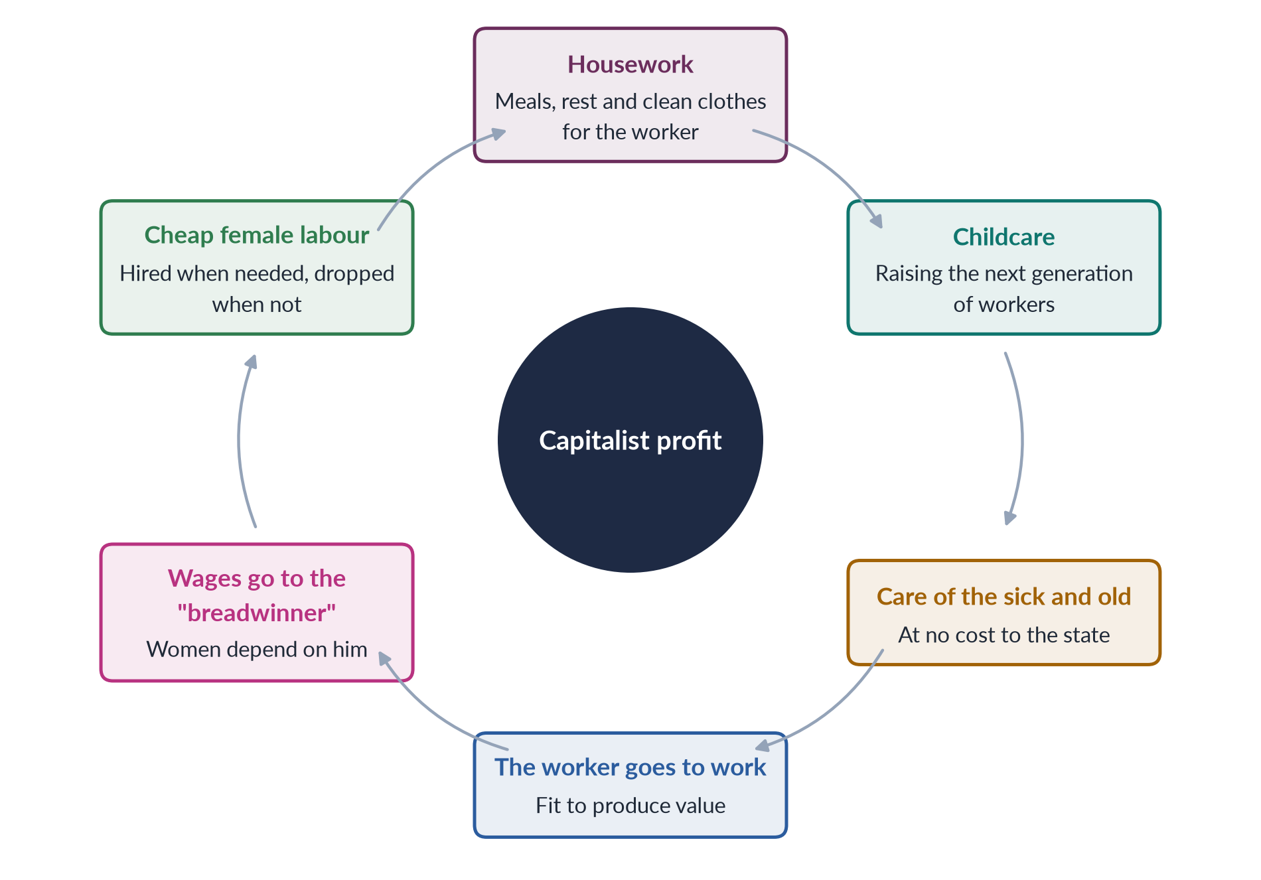
Figure 10 · How women's unpaid work at home keeps capitalism running (the Marxist-feminist view).

4.4 From Marxist to socialist feminism
By the late 1970s many feminists felt that Marxism was "sex-blind". It explained why workers are exploited, but not why women — in every class — are subordinate to men. Why do male workers also dominate their wives? Why did women in socialist countries still do all the housework?
✦ THINKER
Juliet Mitchell · "Women: The Longest Revolution" (1966); *Woman's Estate* (1971)
Mitchell said women's position is shaped by four structures, not only the economy: production, reproduction, sexuality and the socialisation of children. Change in one alone will not free women.
➜ A bridge from Marxist to socialist feminism. (She also defended psychoanalysis — Chapter 5.)

✦ THINKER
Heidi Hartmann · "The Unhappy Marriage of Marxism and Feminism" (1979)
Hartmann compared the union of Marxism and feminism to a marriage in English common law, where "husband and wife are one, and that one is the husband": Marxism had swallowed feminism. She called for a "healthier marriage" and a "divorce" if needed. Her dual-systems theory says capitalism and patriarchy are two separate but linked systems. For example, male-dominated trade unions fought for a "family wage" for men, which pushed women back into the home — capitalism and patriarchy working together.
➜ Hartmann is the name to quote for socialist feminism.

- Zillah Eisenstein (ed., Capitalist Patriarchy and the Case for Socialist Feminism, 1979) coined the term capitalist patriarchy for the single combined system.
- Iris Marion Young ("Beyond the Unhappy Marriage", 1980) argued for a unified-systems theory: capitalism was patriarchal from the start, because it relied on a gendered division of labour.
- Maria Mies (Patriarchy and Accumulation on a World Scale, 1986) described "housewifisation": women's work everywhere — in homes, fields and export factories of the global South — is treated as secondary and paid little, which makes it profitable.
- Sylvia Walby (Theorizing Patriarchy, 1990) identified six structures of patriarchy: paid work, household production, culture, sexuality, violence and the state.
✦ DEFINITION
Socialist feminism · the school of two systems
The view that women are oppressed by capitalism and patriarchy working together. It studies both paid work and unpaid domestic work, both class and gender, and seeks change in the economy and the family at the same time.
➜ Key words: dual systems, capitalist patriarchy, family wage, double burden, social reproduction.

4.5 Marxist and socialist feminism compared
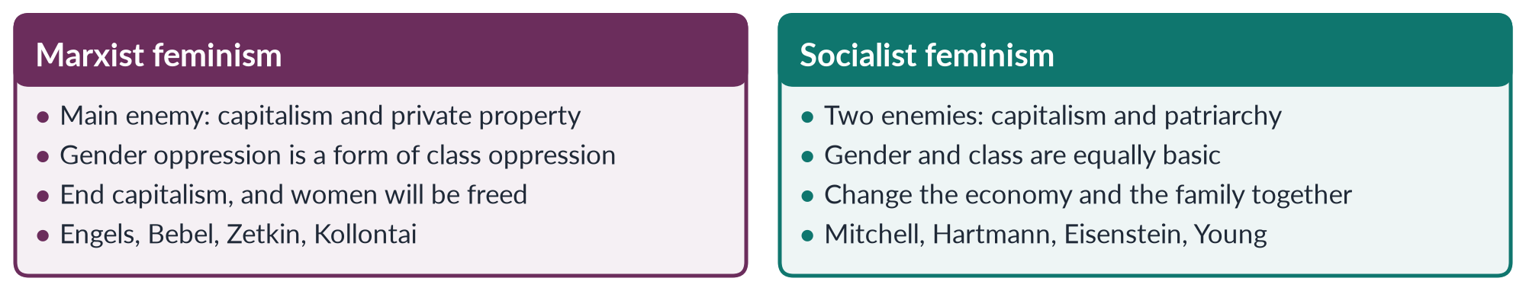
Figure 11 · Marxist feminism and socialist feminism side by side.
Table 8 · Marxist and socialist feminism on the four questions.
Question | Marxist | Socialist
Cause | Capitalism and private property | Capitalism and patriarchy together
Where | The economy; class relations | The economy and the family, sexuality, the state
Remedy | Socialist revolution; women in paid work; socialised housework | Change both systems: paid care, shared housework, workers' and women's rights
Method | Class struggle; trade unions; socialist parties | Alliances of women's and workers' movements; campaigns on care and pay

4.6 Stance on gender and exploitation — the key points
The 2021 question asked for the "philosophical stance" of the school. It can be summarised in six points.
1. Materialism: women's position is explained by material (economic) conditions, not by nature or ideas alone.
2. Two kinds of exploitation: women are exploited as paid workers (low wages, insecure jobs) and as unpaid workers (housework and care).
3. The double burden: women who take paid work still do the housework — a "second shift" (a phrase made famous by sociologist Arlie Hochschild, 1989).
4. The family serves capital: it produces and maintains workers cheaply and passes on property.
5. Reserve army: women are drawn into work in booms or wars and pushed out in slumps.
6. Liberation requires economic change: legal equality is not enough without economic independence and socialised care (public childcare, paid leave).

4.7 Strengths and criticisms
Table 9 · The case for and against Marxist and socialist feminism.
Strengths | Criticisms
Makes unpaid care work visible and measurable | Marxism is "sex-blind": it cannot explain male power within the working class (Hartmann)
Links gender to class: poor women's problems differ from rich women's | Reduces gender to economics; violence and sexuality are underplayed
Explains the double burden and low-paid "women's jobs" | Socialist states did not free women: Soviet women carried a double burden
Global reach: export factories, migrant care workers | Wages for housework could fix women in the home
Influences policy: time-use surveys, care economy, SDG target 5.4 | Dual-systems theory struggles to say how the two systems connect

4.8 Marxist and socialist feminism in Pakistan
This school fits Pakistan's economic realities closely.
- Unpaid family work. Most employed women in Pakistan work in agriculture, much of it as unpaid family helpers (Labour Force Survey). Their labour on crops and livestock is often not counted as "work".
- Home-based workers. Millions of women stitch, embroider, make bangles or pack goods at home for piece rates. Sindh passed Pakistan's first Home-Based Workers Act in 2018.
- Lady Health Workers. The national Lady Health Worker Programme (1994) employs tens of thousands of women. Their long campaign for regular jobs and fair pay — including protests in Islamabad and a Supreme Court order of 2012 to regularise them — is a classic socialist-feminist struggle over women's paid care work.
- Peasant women's movements. The Sindhiani Tehreek (from 1982) organised rural Sindhi women against military rule and feudal power. In the Okara military farms dispute (from 2000), women tenants' groups defended their land with sticks and wooden beaters.
- Social protection. The Benazir Income Support Programme (2008) pays cash to women in poor households — recognising women's role in family survival and giving them some money of their own.
- Left-wing feminist groups such as the Women Democratic Front (founded 2018) link women's rights to workers' rights and are active in the Aurat March.
PAKISTAN ANGLE · THE DOUBLE BURDEN IN ONE PAKISTANI LIFE
A woman in rural Punjab rises before dawn to milk the buffalo, cooks for a joint family, works in the cotton fields in picking season for low wages, collects water and fuel, and cares for children and in-laws. The survey may record her as "not in the labour force". Marxist and socialist feminism give you the words for her situation: unpaid labour, social reproduction, double burden and reserve army.

EXAMINER'S EYE · THE MODEL STRUCTURE FOR 2021
1. Introduction: definition from the question's own words; Engels's thesis. 2. The Marxist background (five terms). 3. Development — classical (Engels, Bebel, Zetkin, Kollontai). 4. The domestic-labour debate (Benston, Dalla Costa and James, Federici). 5. The turn to socialist feminism (Mitchell, Hartmann, Eisenstein, Young). 6. The philosophical stance — six points. 7. Exploitation: paid, unpaid, double burden. 8. Criticisms. 9. Pakistan. 10. Conclusion. Draw the cycle of unpaid work, and the Marxist/socialist comparison.

Chapter 5 · Psychoanalytic Feminism
Psychoanalytic feminists look for the roots of women's subordination inside the mind — in the unconscious, and in what happens to boys and girls in early childhood within the family. They began by attacking Freud and ended by re-reading him. The 2021 question described the school as "a theory of oppression which asserts that men have an inherent psychological need to subjugate women" and asked for "a detailed analysis of gender oppression and women's subordination" in its terms.

5.1 What psychoanalysis is
Psychoanalysis is a theory of the mind, and a method of therapy, founded by the Austrian doctor Sigmund Freud (1856–1939). Its main ideas, in simple words:
- The unconscious. Much of what we feel and want is hidden from us. It shows itself in dreams, slips of the tongue and symptoms.
- Childhood shapes the adult. Our personality — including our sense of being male or female — is formed in the first years of life, mostly in relations with our parents.
- Sexuality is central. Freud believed children pass through stages of sexual development, each centred on a part of the body.
✦ DEFINITION
Psychoanalytic feminism · the school of the mind
The view that women's oppression is rooted deep in the psyche — in the unconscious and in the way early childhood in the family produces "masculine" and "feminine" personalities. Men's need to dominate, and women's acceptance of a secondary role, are formed before a child can reason. Change therefore requires changes in childrearing and in the cultural meanings that shape the unconscious.
➜ Key words: unconscious, Oedipus complex, penis envy, womb envy, mothering, separation, the symbolic order.

5.2 Freud's account of femininity — the starting point
✦ THINKER
Sigmund Freud · "Some Psychical Consequences of the Anatomical Distinction Between the Sexes" (1925); "Femininity" (1933)
Freud said that around the age of three to five children pass through the Oedipus complex. A boy desires his mother, sees his father as a rival, fears punishment by castration, and so gives up the mother and identifies with the father. This builds a strong conscience (superego). A girl discovers she has no penis, feels inferior (penis envy), blames her mother, and turns to her father — wishing later for a baby, especially a son, as a substitute. Freud concluded that women have a weaker superego, and are more passive and vain.
➜ Freud adapted a phrase of Napoleon: "Anatomy is destiny" (1924). He also asked, according to his biographer Ernest Jones, "What does a woman want?"

IN SIMPLE WORDS
In Freud's story, the boy becomes a "man" by joining his father's side, and the girl becomes a "woman" by accepting that she lacks something. Feminists saw at once that this story made male superiority look natural.

5.3 Stage one: the attack on Freud
- Karen Horney (German-American psychoanalyst), in "The Flight from Womanhood" (1926), replied that girls envy not the penis itself but the social power and freedom that men enjoy. She also proposed womb envy: men envy women's ability to create life, and compensate through achievement and domination. This fits the 2021 wording — men's "psychological need to subjugate women" comes from envy and insecurity.
- Clara Thompson (1940s) argued that "penis envy" was really envy of men's cultural privilege.
- Simone de Beauvoir (The Second Sex, 1949) rejected "anatomy is destiny": what matters is not the body but the meaning society gives it.
- Betty Friedan (1963) and Kate Millett (1970) blamed Freud's ideas, spread by 1950s psychologists and magazines, for keeping women in the home.

5.4 Stage two: re-reading Freud
✦ THINKER
Juliet Mitchell · *Psychoanalysis and Feminism* (1974)
Mitchell surprised feminists by defending Freud. She argued that Freud did not approve of patriarchy; he described how patriarchal culture enters each child's mind. "Psychoanalysis is not a recommendation for a patriarchal society, but an analysis of one." If we understand how the unconscious absorbs patriarchy, we can understand why it is so hard to change.
➜ Her book made psychoanalysis a tool for feminists rather than an enemy.

5.5 Stage three: object-relations theory — mothering
The most influential psychoanalytic feminists shifted attention from the father and the penis to the mother and the child's first relationship.
✦ THINKER
Dorothy Dinnerstein · *The Mermaid and the Minotaur* (1976)
Because women alone care for infants, every child's first experience of total dependence, love, frustration and fear is with a woman. As adults, both sexes carry an unconscious fear of female power, which they manage by keeping women under control. Men flee into the outside world of power; women accept a dependent role.
➜ Her remedy: shared parenting by men and women from birth.

✦ THINKER
Nancy Chodorow · *The Reproduction of Mothering* (1978)
Since mothers do most early care, a girl grows up in continuity with her mother. She develops a relational self — she defines herself through connection and wants to care for others. A boy must become "not-mother". He develops a self based on separation, denies feelings and devalues the feminine in order to feel masculine. So each generation of mothering reproduces the gender division: women mother, and men dominate.
➜ Her remedy: dual parenting. If fathers shared early care, boys would not need to reject the feminine to become men.

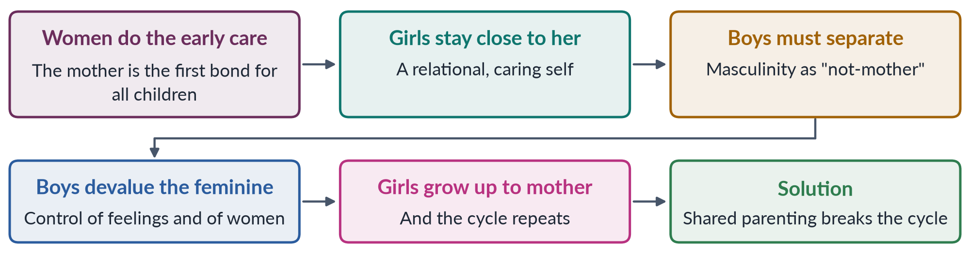
Figure 12 · Chodorow's argument: how women's mothering reproduces gender inequality.
✦ THINKER
Carol Gilligan · *In a Different Voice* (1982)
Gilligan, a psychologist, criticised her teacher Lawrence Kohlberg, whose scale of moral development placed most women lower than men. She argued women often reason by an ethic of care — responsibility and relationships — rather than an ethic of justice — rules and rights. This is a "different voice", not a lesser one.
➜ Often grouped with psychoanalytic and "difference" feminism.

5.6 Stage four: the French feminists and Lacan
The French psychoanalyst Jacques Lacan (1901–1981) reread Freud through language. He argued that the child enters the symbolic order — the world of language, law and culture — through the "Law of the Father". The phallus is not the penis but the symbol of power and meaning. Culture is therefore male-centred from the start: women can enter language only as "lack".
Three French feminists answered Lacan:
- Luce Irigaray (Speculum of the Other Woman, 1974; This Sex Which Is Not One, 1977) argued that Western thought treats woman only as a mirror of man. She called for a female language and identity of their own.
- Julia Kristeva (Revolution in Poetic Language, 1974) described the semiotic — the rhythms and feelings of the child's pre-verbal bond with the mother — which disturbs the male-ordered symbolic, especially in poetry.
- Hélène Cixous ("The Laugh of the Medusa", 1975) called on women to "write their bodies" — écriture féminine ("feminine writing"). A 2024 MCQ asked who presented this term: Hélène Cixous.
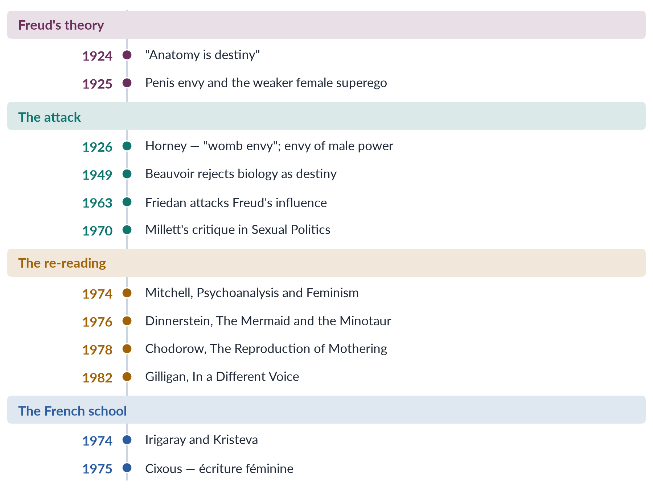
Figure 13 · The development of psychoanalytic feminism.

5.7 How psychoanalytic feminism explains women's subordination
The 2021 question asked for "a detailed analysis of gender oppression". Psychoanalytic feminism gives six explanations.
1. Men's fear and envy. Men's need to dominate grows from unconscious fear of female power (Dinnerstein) and envy of women's creative capacity (Horney).
2. Masculinity as rejection. Boys build manhood by rejecting the mother and all that is "feminine" (Chodorow); contempt for women is built into masculine identity.
3. Femininity as self-sacrifice. Girls learn to define themselves through caring for others, making them accept secondary roles.
4. Mothering reproduces itself. Because women mother, the pattern repeats in every generation.
5. Culture is male-centred. Language and law — the symbolic order — speak from a male position (Lacan, Irigaray).
6. Internalisation. Oppression is not only outside women; it lives inside their desires and self-images, which is why women sometimes support their own subordination.
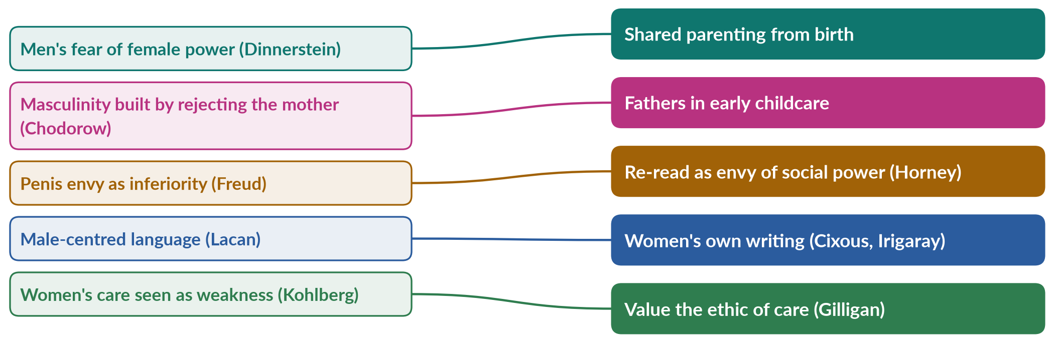
Figure 14 · Psychoanalytic explanations of women's subordination, and the remedies proposed.

5.8 Criticisms
1. Unscientific. The unconscious and the Oedipus complex cannot be tested or disproved.
2. Universalises one family type. It assumes a Western nuclear family with a mother at home. In joint families many women — grandmothers, aunts, older sisters — share care.
3. Ignores material conditions. It explains oppression by the mind, not by law, money or violence (socialist and liberal criticism).
4. Mother-blaming. It can seem to blame mothers for reproducing patriarchy.
5. Heteronormative. It assumes a mother–father family and normal "heterosexual" development.
6. Too abstract. Lacanian and French writing is hard to read and hard to turn into policy.

5.9 Psychoanalytic feminism in Pakistan
The theory is Western, but several of its insights fit Pakistani family life strikingly well.
- Son preference. Families celebrate sons, and a mother's status often rises with sons. A daughter learns early that she is valued less — the "inferiority" Horney attributed to social privilege, not anatomy.
- Separation of boys. Boys are moved into male spaces — the baithak, the mosque, the street — and taught not to cry. This matches Chodorow's picture of masculinity built on separation from the mother and the feminine.
- The mother–son bond. In a joint family, a woman's security in old age often depends on her son, which strengthens this bond and can set her against her daughter-in-law. Deniz Kandiyoti called this the patriarchal bargain (Chapter 8).
- Internalised control. Many women defend customs that restrict them, such as limits on mobility — the "internalisation" psychoanalytic feminists describe.
- The remedy of shared parenting. Growing numbers of urban fathers take part in childcare; paternity leave remains limited. The theory suggests these changes matter more than they seem.
BALANCED VIEW · IS THE 2021 CLAIM TRUE — DO MEN HAVE AN "INHERENT" NEED TO SUBJUGATE WOMEN?
The question's wording overstates the school. Freud treated differences as innate, but most psychoanalytic feminists say men's need to dominate is produced by a particular way of raising children — and can be changed. In your answer, correct the word "inherent": the need is deep-seated and unconscious, but not natural or permanent.

Chapter 6 · Men's Feminism
The syllabus line "men's feminism" covers men who support feminist goals and the study of how patriarchy shapes men's own lives. It asks three questions: Can men be feminists? Why should they be? And what can they do? Topic 1 (Chapter 9) taught you masculinity studies and Connell's hegemonic masculinity; this chapter is about men as allies in feminist practice.

6.1 What "men's feminism" means
✦ DEFINITION
Men's feminism · also called male feminism or pro-feminism
The support of men for gender equality and women's rights, together with the analysis of how patriarchy shapes and harms men as well as women. Men's feminists work to change masculinity, men's behaviour and the institutions men control.
➜ Many men in the movement prefer the word pro-feminist, meaning they support feminism without claiming to speak for women.

The idea rests on two points:
1. Men hold much of the power — in families, parliaments, mosques, courts, police and companies. Change is faster when men with power support it.
2. Patriarchy has costs for men too. Rigid manhood pushes men into violence, risk-taking, emotional silence and the pressure of being the sole breadwinner.

6.2 A long history of male supporters
Table 10 · Men who argued for women's rights before the modern movement.
Man | Year | Contribution
Marquis de Condorcet (France) | 1790 | On the Admission of Women to the Rights of Citizenship
Raja Ram Mohan Roy (Bengal) | 1829 | Campaigned against sati (widow burning), banned in 1829
Frederick Douglass (USA) | 1848 | The only African-American signer of the Seneca Falls Declaration of Sentiments
Ishwar Chandra Vidyasagar (Bengal) | 1856 | Campaigned for the Hindu Widows' Remarriage Act
John Stuart Mill (Britain) | 1869 | The Subjection of Women; proposed votes for women (1867)
Sayyid Mumtaz Ali (Lahore) | 1898 | Huquq-un-Niswan, women's rights argued from Islam
Qasim Amin (Egypt) | 1899 | The Liberation of Women
Sheikh Abdullah "Papa Mian" (Aligarh) | 1906 | Founded a girls' school that became Aligarh Women's College
Quaid-e-Azam M. A. Jinnah | 1944 | "No nation can rise to the height of glory unless your women are side by side with you"

PAKISTAN ANGLE · MALE SUPPORTERS IN PAKISTAN TODAY
• Ziauddin Yousafzai, a teacher from Swat and father of Malala, built a girls' school and defended his daughter's education; he wrote Let Her Fly (2018).
• The NGO Rozan (Islamabad) has worked since the late 1990s with boys, young men and police on gender, emotional health and violence.
• Men have marched alongside women in the Aurat March, and male religious scholars have spoken for women's inheritance rights and against forced marriage.

6.3 The thinkers of men's feminism
- R. W. (Raewyn) Connell (Masculinities, 1995) — hegemonic masculinity and the patriarchal dividend, the advantage all men gain from women's subordination, even men who do not want it (Topic 1, Chapter 9).
- Michael Kimmel (Manhood in America, 1996; Guyland, 2008) — manhood is a constant test that men must pass in front of other men; "homophobia" in his sense is men's fear of being seen as unmanly.
- Michael Messner (Politics of Masculinities: Men in Movements, 1997) — mapped men's movements by how they treat men's privileges, the costs of masculinity, and the differences among men.
- bell hooks (Feminism Is for Everybody, 2000; The Will to Change, 2004) — patriarchy damages men emotionally; feminism is "for everybody", and men must be invited in.
- Michael Flood — Australian researcher on engaging men in preventing violence against women.
✦ THINKER
bell hooks · *The Will to Change: Men, Masculinity, and Love* (2004)
hooks argued that patriarchy teaches boys to kill off their emotional lives in order to be "real men". Men are therefore also wounded by patriarchy, and a feminist world would give them the freedom to love and to feel.
➜ Use her to show that men's feminism is not charity for women but liberation for men as well.

6.4 Men's movements: allies and opponents
Not every "men's movement" is feminist. Messner and others distinguish four broad kinds.
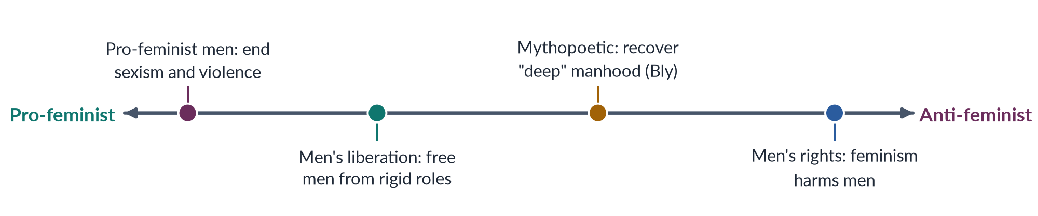
Figure 15 · Men's movements, from pro-feminist to anti-feminist.
1. Pro-feminist men accept that men hold unfair privilege and work to end sexism and violence. Example: the US National Organization for Men Against Sexism (NOMAS).
2. Men's liberation (1970s) stressed the costs of the male role — stress, early death, emotional isolation — and wanted to free men from it.
3. The mythopoetic movement, led by the poet Robert Bly (Iron John, 1990), held retreats to help men recover a "deep masculine" spirit. Critics said it ignored women and power.
4. Men's rights activists claim that feminism has gone too far and that men are now the victims — in divorce, child custody and false accusations. They are generally anti-feminist, and some online groups spread hostility to women.

6.5 Global campaigns engaging men
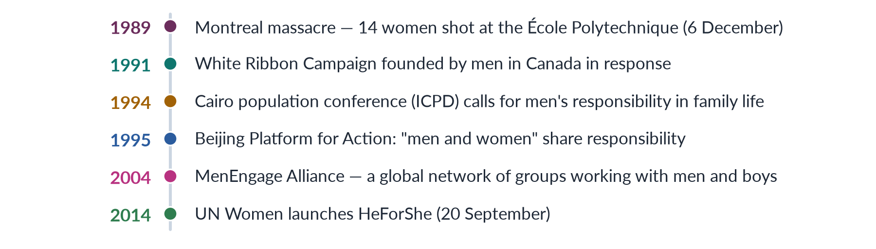
Figure 16 · Campaigns that bring men into feminist practice.
- The White Ribbon Campaign (1991) asks men to wear a white ribbon as a pledge never to commit, excuse or stay silent about violence against women. It has spread to many countries.
- HeForShe, launched by UN Women with a speech by the actor Emma Watson on 20 September 2014, invites men and boys to commit to gender equality.
- The ICPD in Cairo (1994) placed "male responsibility" for sexual and reproductive health and family life on the international agenda.

6.6 How patriarchy harms men — the evidence men's feminists use
- Shorter lives. Men worldwide die younger than women, partly because of risk-taking, smoking, dangerous work and reluctance to seek medical help.
- Suicide. In most countries men die by suicide at higher rates than women, a pattern researchers link to emotional silence and pressure to provide.
- Violence. Men are most of the victims, as well as most of the perpetrators, of homicide.
- The provider burden. In Pakistan, young men carry the pressure to earn for parents, sisters' dowries and a family — a burden that drives migration and debt.
- Loss of fatherhood. Rigid roles keep many fathers distant from their children.

6.7 The debate: can men really be feminists?
HOT DEBATE · MEN AND FEMINISM
• Yes — welcome them. hooks: feminism is a movement against sexism, not against men. Men hold power and can change laws, families and other men's attitudes; change is impossible without them.
• Yes — but as allies, not leaders. Men cannot fully know women's experience; they should listen, support and use their privilege to open doors, without taking over the platform or the funds.
• Be careful. Some men use a feminist image for status, while behaving badly in private. Critics have also warned that projects "for men" can divert scarce resources from women's own organisations.
• No. A small number of radical feminists say men benefit from patriarchy and cannot be trusted to dismantle it.
➜ The widely accepted position today: men can and should be pro-feminist allies, accountable to women's organisations.

6.8 What men's feminism asks men to do
1. At home: share housework and childcare; respect wives' and daughters' choices on education, work and marriage.
2. At work: equal pay and promotion; act on harassment complaints; support maternity and paternity leave.
3. In public: challenge other men's jokes, harassment and violence — "bystander" action.
4. In law and religion: support women's inheritance, consent in marriage and protection from violence.
5. In themselves: unlearn the idea that being a man means control, anger and silence.
PAKISTAN ANGLE · ENGAGING MEN IN PAKISTAN: WHY IT MATTERS
Most decisions that shape a Pakistani woman's life — about schooling, marriage, mobility, work and inheritance — are made or approved by fathers, brothers, husbands and elders. Campaigns that address only women often fail at the family gate. Working with fathers (for girls' schooling), religious leaders (for consent and inheritance), police (for gender-sensitive handling of complaints) and young men (on respectful relationships) is therefore not an extra — it is essential.

6.9 Criticisms of men's feminism
1. Centring men. It can shift attention from women's suffering to men's feelings.
2. Privilege remains. Male allies still enjoy the patriarchal dividend; commitment can be shallow.
3. Slippage. Talk of men's "costs" can slide into the anti-feminist men's-rights view.
4. Speaking for women. Men may dominate discussions even in feminist spaces.
5. Evidence. Some programmes with men show good results in changing attitudes, but lasting change in behaviour is harder to prove.

Chapter 7 · Postmodern and Post-structural Feminism
Postmodern feminism is the hardest school to grasp, and one of the most tested. It says there is no single "woman", no single cause of oppression and no single truth; identities are made in language and discourse, and they shift. Two MCQs (2018, 2023) asked what post-structural feminism emphasises; the answer both times was the contingent and discursive nature of identities. A 2019 MCQ linked gender equality constructed through literature to postmodern feminism. The school was a short note in 2019.

7.1 Two hard words made simple
✦ DEFINITION
Contingent · as used in the MCQ
Not fixed or necessary; depending on circumstances, and able to be otherwise. A contingent identity is one that could have been different and can change.

✦ DEFINITION
Discursive · as used in the MCQ
Produced by discourse — the ways a society talks, writes and thinks about something, including the rules about who may speak and what counts as true. A discursive identity is one made by language and ideas, not by nature.
➜ So "the contingent and discursive nature of identities" means: who we are is shaped by the language of our time and place, and can change.

7.2 Postmodernism in general
Modernism here means the Enlightenment belief in reason, science, progress and universal truths. Liberal feminism (all humans have reason and rights) and Marxist feminism (history moves towards the freedom of the oppressed class) are both "modern" theories.
Postmodernism, from the late 1960s onwards, doubts these big claims.
✦ THINKER
Jean-François Lyotard · *The Postmodern Condition* (1979)
Lyotard defined the postmodern as "incredulity toward metanarratives" — disbelief in the grand stories, such as progress, reason or class revolution, that claim to explain everything.
➜ For feminists, "patriarchy explains all women's oppression" is also a grand story.

Two other French thinkers supplied the tools:
- Jacques Derrida (Of Grammatology, 1967) developed deconstruction: Western thought is built on pairs of opposites — reason/emotion, culture/nature, man/woman — in which the first term is ranked above the second. Deconstruction exposes and unsettles these ranked pairs. (Topic 1, Chapter 7 applied this to the word "gender".)
- Michel Foucault (Discipline and Punish, 1975; The History of Sexuality, 1976) argued that power and knowledge are joined. Power is not only held by kings or men; it runs through discourses — of medicine, psychiatry, law, education — that define what is "normal" and train our bodies and selves.
IN SIMPLE WORDS
A structuralist thinks meanings are fixed by a stable structure, like the rules of a language. A post-structuralist says meanings are never fully fixed: words get their meaning from their differences from other words, and those meanings shift with time and power. "Woman" meant something different in 1850 London, 1950 Lahore and 2026 Karachi.

7.3 What postmodern feminism says
✦ DEFINITION
Postmodern feminism · the school of difference and discourse
The view that there is no universal category "woman" and no single cause of women's oppression. Gender identities are constructed in language and discourse, are multiple and unstable, and differ by culture, class, race and history. The task is to deconstruct the binaries (man/woman, reason/emotion) and discourses that make women "the Other", and to value plurality and difference.
➜ Key words: anti-essentialism, difference, discourse, deconstruction, plurality, local knowledge, performativity.

Five core ideas:
1. Anti-essentialism. There is no "essence" of womanhood shared by all women.
2. Difference. Women differ by class, race, religion, sexuality, age, nation. Feminism must recognise these differences, not hide them.
3. Language constructs reality. Our ideas of man and woman are made in language; changing language can change reality.
4. Suspicion of grand theories. No single theory — liberal, Marxist or radical — explains all women's oppression.
5. Local and personal knowledge. Women's particular experiences and stories are valued over universal claims. This is why a 2025 MCQ on "the value of women's personal experiences" has postmodern feminism as its suggested key.
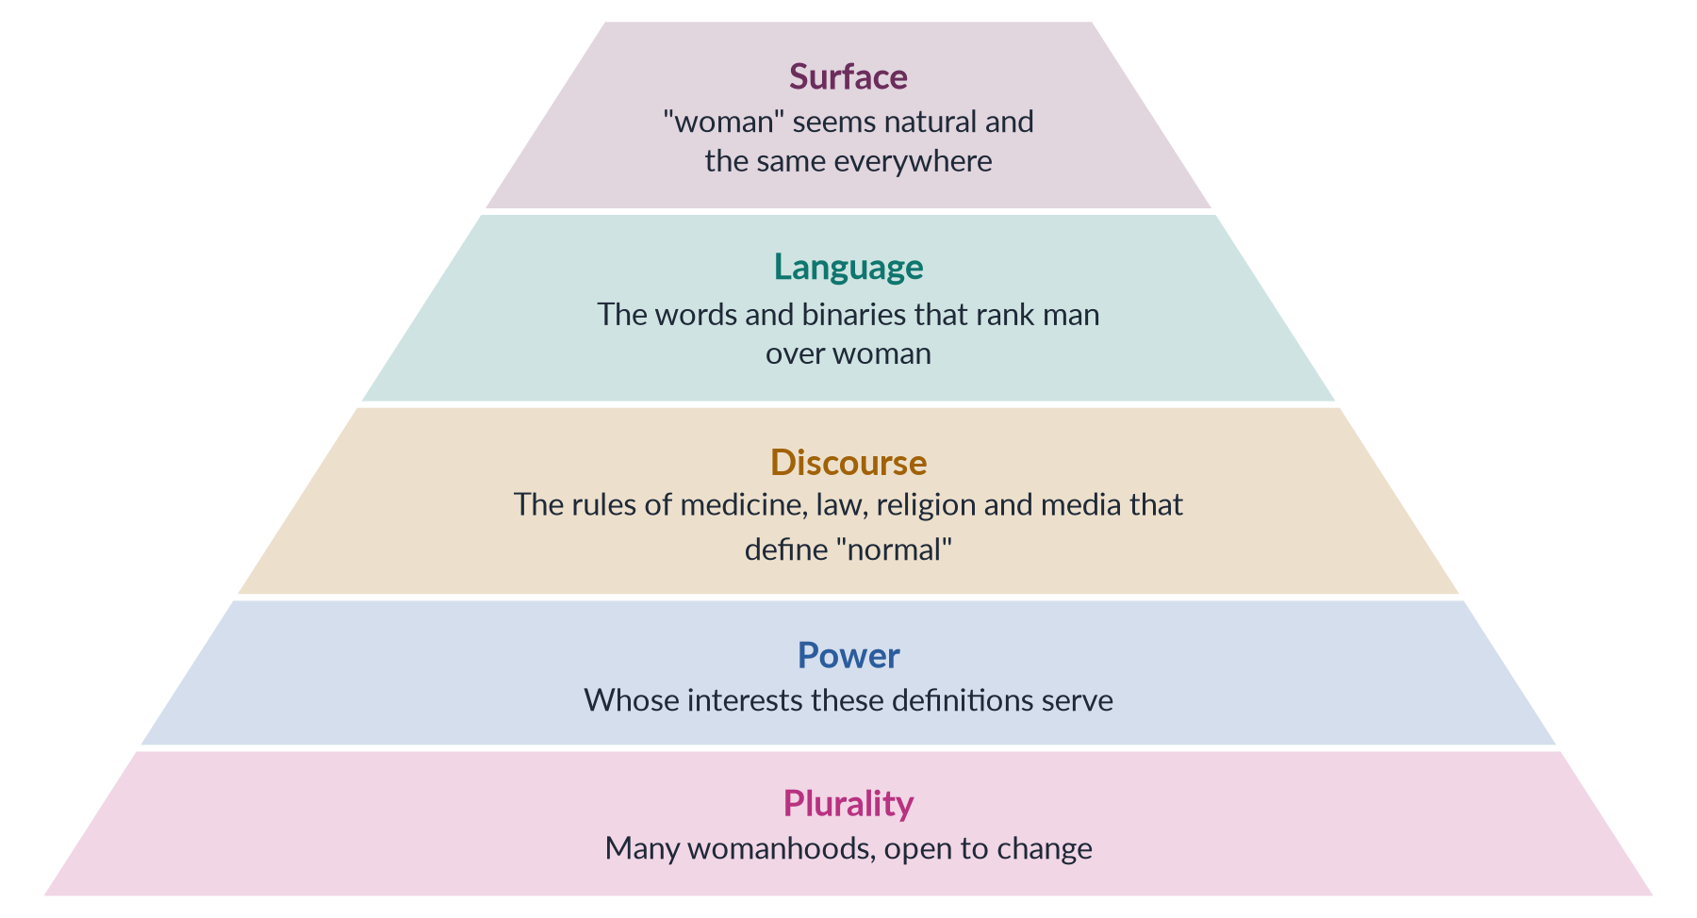
Figure 17 · Postmodern feminism's method: from the surface to what lies beneath.

7.4 The thinkers
✦ THINKER
Judith Butler · *Gender Trouble* (1990); *Bodies That Matter* (1993)
Butler argued that gender is performative: there is no inner gender that our actions express; repeated acts create the appearance of a natural gender. She also criticised feminism's reliance on the category "women", which she said excludes those who do not fit its norms.
➜ The most cited post-structural feminist (Topic 1, Chapter 8).

- Hélène Cixous, Luce Irigaray and Julia Kristeva (Chapter 5) — the "French feminists" — are post-structuralist too. They deconstruct male-centred language and call for écriture féminine. Their work explains the MCQ link between gender equality and literature: writing is where new meanings of woman are made.
- Jane Flax ("Postmodernism and Gender Relations in Feminist Theory", 1987) argued that feminist theory is itself a kind of postmodern philosophy, because it questions the "neutral" male subject.
- Joan W. Scott ("Gender: A Useful Category of Historical Analysis", 1986; "Deconstructing Equality-versus-Difference", 1988) showed that the choice "equal or different?" is a false binary — women need both.
- Donna Haraway ("A Cyborg Manifesto", 1985) used the image of the cyborg — part human, part machine — to reject pure natural identities.
- Chris Weedon (Feminist Practice and Poststructuralist Theory, 1987) explained post-structuralism for feminist practice.
- Nancy Fraser and Linda Nicholson ("Social Criticism without Philosophy", 1988) proposed a middle way: keep large-scale social criticism, but make it historical and aware of difference.
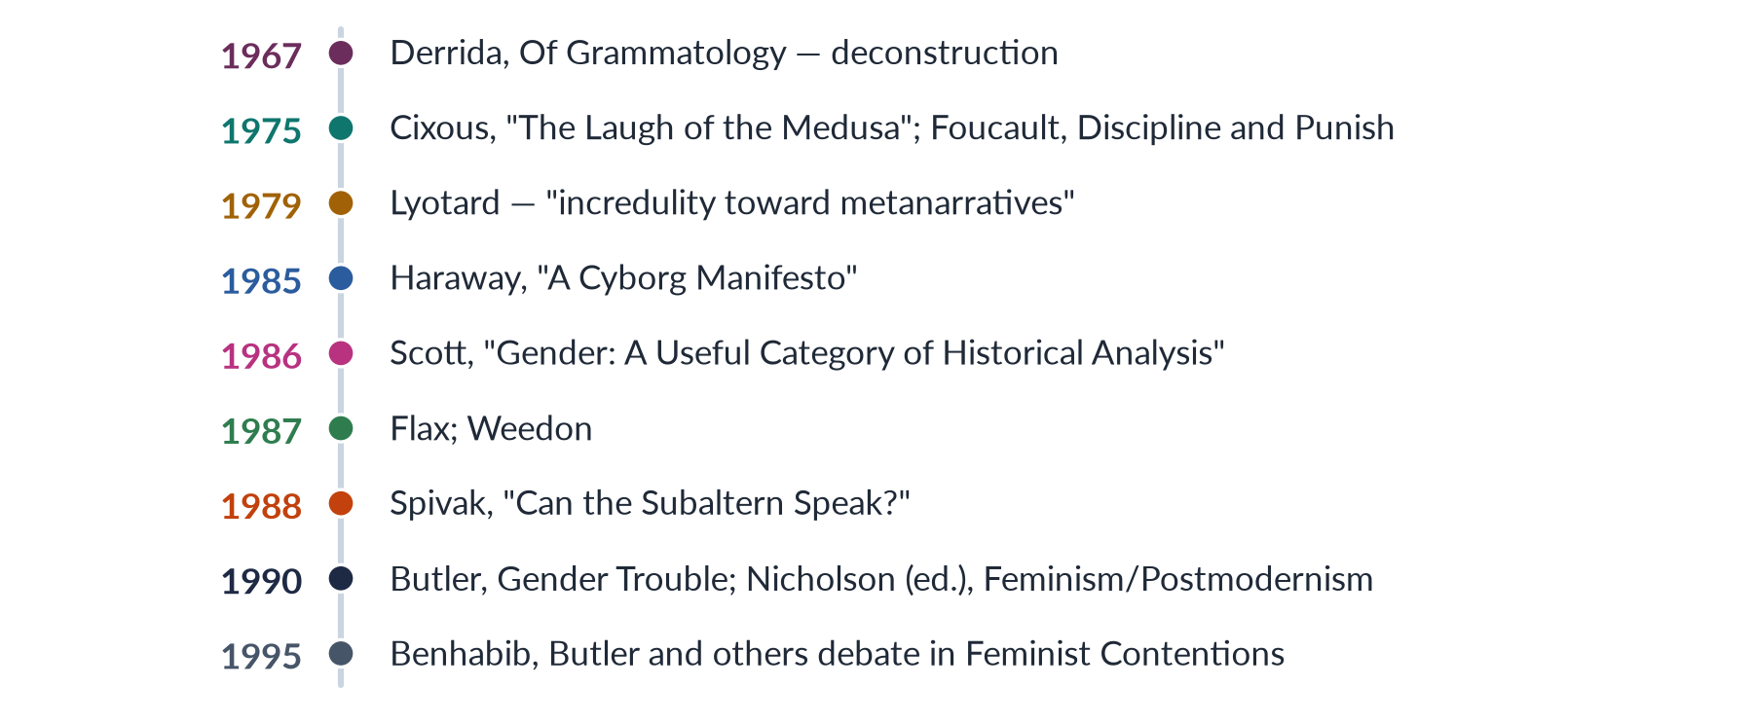
Figure 18 · Milestones of postmodern and post-structural feminism.

7.5 Postmodern and modern feminisms compared
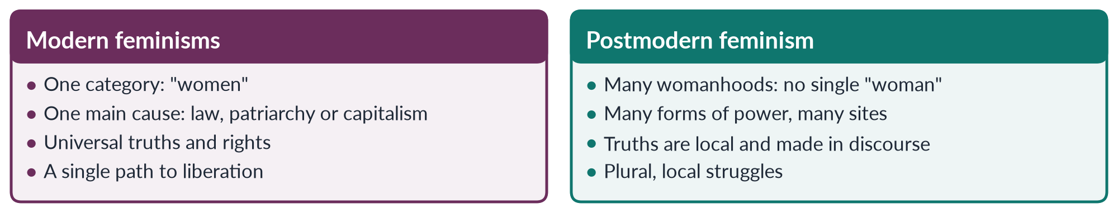
Figure 19 · Modern feminisms and postmodern feminism.

7.6 Strengths
1. Inclusion. It opened space for women left out by earlier theories — women of colour, poor women, Muslim women, lesbians, transgender people.
2. Attention to language and media. It explains how images, words and textbooks shape gender.
3. No false universals. It warns Western feminists against speaking for all women — a lesson for postcolonial and Muslim feminism (Chapter 8).
4. Flexibility. If identities are not fixed, change is always possible.

7.7 Criticisms
1. The "death of the subject". Seyla Benhabib (in Feminist Contentions, 1995) warned that if the self is only a product of discourse, there is no one who can act and resist. Feminism needs agents.
2. Political paralysis. If there is no category "women", on whose behalf does feminism speak? Laws, quotas and statistics all need the category.
3. Relativism. If all truths are local, how can we condemn honour killing or child marriage as wrong everywhere?
4. Jargon and elitism. Martha Nussbaum ("The Professor of Parody", 1999) criticised Butler's obscure style and its distance from poor women's struggles.
5. Neglect of material life. Hunger, wages and violence are not only "discourse" (socialist criticism).
✦ THINKER
Gayatri Chakravorty Spivak · Indian-born theorist · strategic essentialism
Spivak suggested a way out of the "political paralysis" problem: strategic essentialism — groups can temporarily act as if they share a single identity ("women", "workers") to win political goals, while knowing that the identity is not really fixed.
➜ A 2026 MCQ asked what strategic essentialism suggests: temporary strategic unity around an identity.

BALANCED VIEW · IS POSTMODERN FEMINISM USEFUL FOR A COUNTRY LIKE PAKISTAN?
Useful: it warns against speaking of "the Pakistani woman" as if a Karachi banker, a Tharparkar peasant, a Hazara widow and a khawaja sira shared one life. It exposes how discourses — of "honour", "modesty" or "Western agenda" — shape what women may do. Limited: its abstract language is far from urgent needs such as schools, clinics and protection from violence, and relativism can be used to excuse harmful customs. The line to take: use its insights on difference and discourse, and Spivak's strategic essentialism, while keeping universal human rights as the floor.

7.8 Postmodern feminism and Pakistan: examples
- Discourses of honour. "Ghairat" is not a natural feeling but a discourse, taught and repeated, that defines a woman's body as her family's property. Deconstructing it is the first step to challenging honour crimes.
- Media and advertising. Fairness-cream adverts and TV dramas construct an ideal woman — fair, modest, self-sacrificing. Postmodern analysis shows how these images are made and whose interests they serve.
- Literature. Pakistani women poets such as Kishwar Naheed and Fahmida Riaz used poetry to challenge the language of female obedience. Kishwar Naheed's poem "We Sinful Women" (Hum Gunahgar Auratein) became an anthem of the 1980s women's movement; its English translation gave the title to an anthology edited by Rukhsana Ahmad (1991). This is feminism working through literature — the idea behind the 2019 MCQ.
- Many womanhoods. Class, province, language, sect and disability produce very different experiences of being a woman in Pakistan — the starting point of the intersectional analysis in Chapter 8.
EXAMINER'S EYE · SHORT NOTE ON POSTMODERN FEMINISM (2019)
Define it (no single woman; identities contingent and discursive). Roots (Lyotard 1979, Derrida, Foucault). Thinkers (Butler 1990, Cixous 1975, Irigaray, Kristeva, Flax, Scott). Three or four core ideas. Two strengths. Two or three criticisms (Benhabib, Nussbaum). Spivak's strategic essentialism as the answer to the criticism. One Pakistani example (discourse of honour; women poets). A compare figure — modern versus postmodern — earns extra credit.

Chapter 8 · Beyond the Syllabus Schools: Intersectional, Black, Postcolonial, Eco- and Muslim Feminism
The syllabus lists six schools, but the examiner has moved on. The 2025 question asked for "a detailed analysis of the intersectionality of gender with other social identities". The 2024–2026 MCQs asked about Black feminism, standpoint theory, strategic essentialism, kyriarchy, the matrix of domination, the patriarchal bargain and gynocriticism. This chapter teaches all of them.

8.1 Black feminism
In the United States, Black women found that the women's movement was led by white women, and the civil-rights movement by Black men. Neither spoke for them.
- Sojourner Truth, a formerly enslaved woman, spoke at a women's convention in Akron, Ohio, in 1851. The famous version of her speech, with the refrain "Ain't I a woman?", was published by Frances Gage in 1863; historians note that it differs from earlier reports. Its point is clear either way: the ideal of the delicate, protected "lady" never applied to Black women who laboured in the fields.
- The Combahee River Collective Statement (Boston, 1977) said that Black women face "interlocking" oppressions — racial, sexual, heterosexual and class — experienced simultaneously.
- bell hooks (Ain't I a Woman: Black Women and Feminism, 1981; Feminist Theory: From Margin to Center, 1984) criticised white feminism for treating middle-class white women's problems as every woman's problems.
- Audre Lorde ("The Master's Tools Will Never Dismantle the Master's House", 1979) warned feminists not to ignore difference among women.
- Alice Walker coined womanism (In Search of Our Mothers' Gardens, 1983) for Black women's feminism.
✦ DEFINITION
Black feminism · 2025 MCQ
Feminism centred on the experience of Black women, who face race, class and gender oppression together. It differs from mainstream feminism by its focus on all three — the answer to the 2025 MCQ was "all of these".

✦ THINKER
Patricia Hill Collins · *Black Feminist Thought* (1990)
Collins described a matrix of domination: the way intersecting oppressions — race, class, gender, sexuality, nation — are organised across society at several levels (structures, institutions, culture and personal life). She also described Black women as "outsiders within" — for example, domestic workers inside white homes, who see the family from a position no one else has.
➜ A 2026 MCQ asked who developed the matrix of domination: Patricia Hill Collins.

8.2 Intersectionality
✦ THINKER
Kimberlé Crenshaw · "Demarginalizing the Intersection of Race and Sex" (1989); "Mapping the Margins" (1991)
Crenshaw, an American law professor, coined intersectionality. She used the case of DeGraffenreid v. General Motors (1976): Black women laid off by General Motors sued for discrimination. The court said GM hired women (white women, in office jobs) and hired Black people (Black men, on the factory floor), so there was no sex or race discrimination — and refused to combine the two claims. Black women fell between the categories.
➜ Her image: discrimination is like traffic at an intersection; a woman standing where two roads cross can be hit from either direction, or both.

A 2024 MCQ asked where intersectionality originated. The answer: from discussions on gender and race.
✦ DEFINITION
Intersectionality · the key idea of the 2025 question
The idea that a person's social identities — such as gender, race, class, religion, ethnicity, caste, disability, age and sexuality — overlap and interact, producing unique experiences of privilege and disadvantage that cannot be understood by looking at one identity at a time.
➜ It is an analytical tool: it tells you to ask "which women?" before making any claim about "women".

IN SIMPLE WORDS
Being a woman is one disadvantage. Being poor is another. But a poor woman does not simply face "two disadvantages added up". She faces a different situation — for example, she cannot afford private transport, so she depends on unsafe public buses where she is harassed. The overlap creates a problem neither identity creates alone.

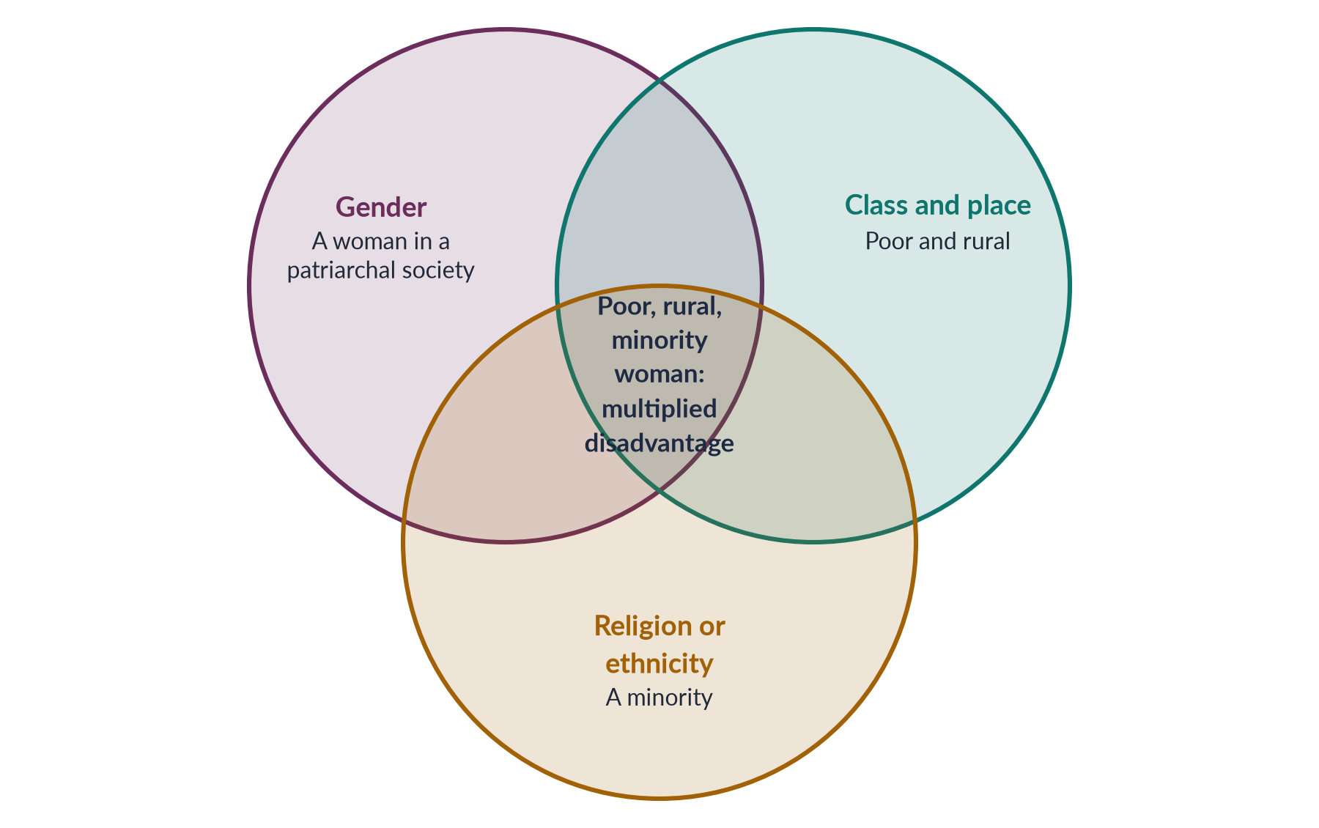
Figure 20 · Intersectionality: overlapping identities create a unique position.

Additive versus intersectional thinking
Table 11 · Two ways of thinking about multiple disadvantage.
| Additive ("single-axis") | Intersectional
Model | Gender + class + religion, added up | Gender × class × religion, interacting
Example | "She faces sexism and also poverty." | "Her poverty changes what sexism means for her: no safe transport, no lawyer, no shelter."
Policy result | One programme for women, another for the poor | Programmes designed for the specific group at the overlap

Intersectionality in Pakistan
- Rural women face distance from schools and clinics on top of gender norms; the literacy gap between urban and rural women is far larger than between urban women and men (Census 2023: female literacy about 53% nationally, much lower in rural areas).
- Religious minority women — Christian, Hindu, Sikh, Ahmadi — face additional risks, including reported cases of forced conversion and marriage of Hindu and Christian girls, especially in Sindh and Punjab.
- Ethnic minorities such as the Hazara community of Quetta have faced targeted violence; Hazara widows carry both community trauma and women's burdens.
- Women with disabilities face barriers of access, stigma and marriage prospects that other women do not.
- Khawaja siras are at the intersection of gender identity, poverty and social exclusion (Topic 1).
- Class: a professional woman in Islamabad may hire a domestic worker, who is herself a woman with no labour protection — the privilege of one woman rests on the disadvantage of another.

8.3 Standpoint theory
✦ DEFINITION
Standpoint theory · 2026 MCQ
The view that knowledge is socially situated: what people can see and know depends on their position in society. Those at the bottom of a power structure can see things that those at the top miss, so starting research from women's lives produces more complete knowledge.
➜ Roots: Hegel's master and slave, and Marx's view that the working class sees capitalism more clearly than the owners.

- Nancy Hartsock ("The Feminist Standpoint", 1983) — a Marxist-feminist version.
- Dorothy Smith (The Everyday World as Problematic, 1987) — sociology should start from women's everyday lives.
- Sandra Harding (The Science Question in Feminism, 1986) — "strong objectivity": science becomes more objective when it includes the views of the marginalised.
- Patricia Hill Collins (1990) — Black women's standpoint.

8.4 Postcolonial feminism
Postcolonial means "after colonialism": it studies how colonial rule shaped, and still shapes, the ideas and lives of formerly colonised peoples.
✦ THINKER
Chandra Talpade Mohanty · "Under Western Eyes: Feminist Scholarship and Colonial Discourses" (1984; revised 1986)
Mohanty criticised Western feminist writing for creating a single "Third World Woman" — poor, ignorant, veiled, tradition-bound and a victim — set against the educated, free Western woman. This erases the real variety of women's lives and their own struggles.
➜ The key text of postcolonial feminism.

✦ THINKER
Gayatri Chakravorty Spivak · "Can the Subaltern Speak?" (1988)
The subaltern is the person at the very bottom of colonial society, without a voice in the official record. Writing on the British ban on sati, Spivak summed up the colonial attitude as "White men are saving brown women from brown men". Both the colonisers and local patriarchs spoke about the women; the women themselves were not heard.
➜ Also the source of strategic essentialism (Chapter 7).

- Lila Abu-Lughod ("Do Muslim Women Really Need Saving?", 2002) criticised the use of Afghan women's rights to justify the 2001 war, and the idea that Muslim women need rescue by the West.
- Uma Narayan (Dislocating Cultures, 1997) warned against treating "culture" as fixed, both in Western views of the East and in local claims about "our traditions".
PAKISTAN ANGLE · POSTCOLONIAL FEMINISM AND PAKISTAN
• It answers the charge that feminism is a "Western agenda": postcolonial feminists are themselves critics of Western feminism, and argue for feminisms rooted in local history.
• It also warns against the other extreme — defending every local custom as "our culture", when many harmful laws (such as parts of colonial penal law) and customs have changed over time.
• It shows how colonial law shaped women's lives in the subcontinent — for example, through the codification of personal law and the Penal Code of 1860.

8.5 Ecofeminism
✦ DEFINITION
Ecofeminism · women and nature
The view that the domination of women and the domination of nature are connected: both come from the same patriarchal, profit-driven way of thinking that ranks culture over nature, reason over emotion, and man over woman.
➜ The word was coined by the French writer Françoise d'Eaubonne in Le Féminisme ou la Mort ("Feminism or Death", 1974).

- Carolyn Merchant (The Death of Nature, 1980) argued that the scientific revolution turned nature from a living "mother" into a dead machine to be exploited.
- Vandana Shiva (Staying Alive, 1988), an Indian scientist, argued that colonial and Western "development" destroyed forests, rivers and women's knowledge together. With Maria Mies she wrote Ecofeminism (1993).
- The Chipko movement (Uttarakhand, India, from 1973), in which village women hugged trees to stop logging, became an ecofeminist symbol.
- Wangari Maathai founded the Green Belt Movement in Kenya (1977), in which women planted millions of trees; she won the Nobel Peace Prize in 2004.
BALANCED VIEW · ECOFEMINISM AND ITS CRITICS
Some ecofeminists said women are naturally closer to nature — an essentialist claim. The Indian economist Bina Agarwal ("The Gender and Environment Debate", 1992) proposed feminist environmentalism instead: women's closeness to nature comes from their material work — collecting water, fuel and fodder — not from their biology.
➜ In Pakistan this is the stronger argument: rural women in Thar, Cholistan and flood-hit Sindh depend daily on water and land, which is why climate disasters such as the 2022 floods hit them hardest (Topic 4 and the 2026 question on climate).

8.6 Muslim (Islamic) feminism
✦ DEFINITION
Islamic (Muslim) feminism · gender justice from within Islam
A movement of scholars and activists who seek gender justice by re-reading the Qur'an and Sunnah — separating the divine message from later patriarchal interpretation (tafsir) and custom. It argues that the Qur'an's core values of justice (adl), equality in faith and human dignity support women's rights.
➜ The term spread in the 1990s, partly through the Iranian magazine Zanan (1992) and the historian Margot Badran.

Table 12 · Key thinkers of Muslim feminism.
Thinker | Work | Main idea
Fatima Mernissi (Morocco) | Beyond the Veil (1975); The Veil and the Male Elite (1987) | Questioned the chains of transmission of hadith used against women
Amina Wadud (USA) | Qur'an and Woman (1992) | Read the Qur'an from a woman's perspective; stressed equal creation and moral agency
Leila Ahmed (Egypt/USA) | Women and Gender in Islam (1992) | Traced how women's status changed in Muslim history
Riffat Hassan (Pakistan/USA) | Essays from the 1980s | Showed that the Qur'an does not say woman was created from man's rib
Asma Barlas (Pakistan/USA) | "Believing Women" in Islam (2002) | Argued the Qur'an is anti-patriarchal when read as a whole

- Organisations: Sisters in Islam (Malaysia, 1988) and Musawah ("equality"), a global movement for equality in Muslim family law launched in Kuala Lumpur in 2009.
HOT DEBATE · IS "ISLAMIC FEMINISM" A BRIDGE OR A CONTRADICTION?
• A bridge: it speaks the language of faith that most Pakistani women share; it has legitimacy that secular feminism lacks; many rights — inheritance, mahr, khula, consent to marriage — are already Islamic.
• A contradiction (secular critics): some secular feminists, such as Haideh Moghissi (1999), argue that working inside religion limits how far reform can go. In Pakistan, Afiya Zia (Faith and Feminism in Pakistan, 2018) criticised the turn to faith-based approaches as limiting secular feminist politics.
• A Western agenda (conservative critics): some religious conservatives say it distorts Islam to suit Western ideas.
• Beyond resistance: the anthropologist Saba Mahmood (Politics of Piety, 2005) studied women's mosque movements in Egypt and argued that pious women exercise real agency, even when they do not seek "liberation" in the Western sense.
➜ A balanced answer: in Pakistan, the most successful reforms have combined constitutional rights with Islamic justification — for example, the Council of Islamic Ideology's debates and the courts' support for khula and inheritance.

8.7 Five more terms the MCQs love
Table 13 · Five concepts from recent MCQs.
Term | Thinker | Meaning
Patriarchal bargain | Deniz Kandiyoti, "Bargaining with Patriarchy" (1988) | The strategies women adopt to secure security and power within the limits of a given patriarchy. In "classic patriarchy" (from North Africa across the Middle East to South Asia, including Pakistan), a young bride is powerless, but she can expect power later as a mother of sons and mother-in-law — so women may invest in the system rather than resist it (MCQs 2026).
Kyriarchy | Elisabeth Schüssler Fiorenza, But She Said (1992) | From the Greek kyrios, "lord": interlocking systems of domination — gender, race, class, empire — in which a person may be oppressed in one and privileged in another (MCQ 2026).
Matrix of domination | Patricia Hill Collins (1990) | How intersecting oppressions are organised across society (MCQ 2026).
Gynocriticism | Elaine Showalter ("Toward a Feminist Poetics", 1979; A Literature of Their Own, 1977) | The study of women as writers — their history, themes and traditions (MCQ 2024).
Écriture féminine | Hélène Cixous (1975) | "Women's writing" from the female body and experience (MCQ 2024).

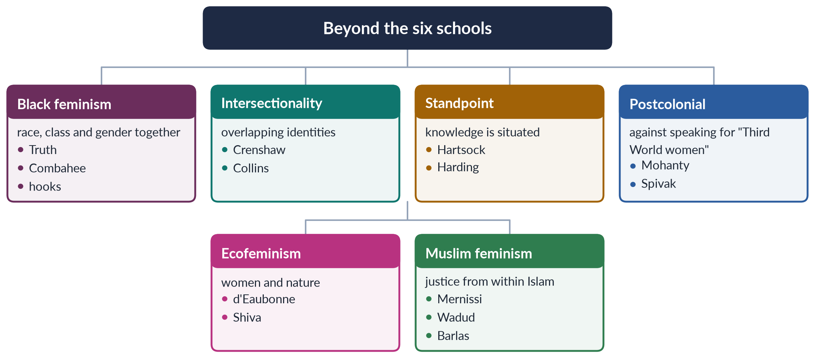
Figure 21 · The newer feminisms at a glance.

Chapter 9 · The Schools Compared — and Which Feminism Suits Pakistan?
This chapter brings the schools together. It gives you the master comparison table, the three comparisons the examiner likes most (radical versus socialist, liberal versus radical, Marxist versus socialist), and a reasoned answer to the 2018 question: "What type(s) of feminism can elevate the socio-cultural, economic and political status of women in Pakistan?"

9.1 The master table
Table 14 · All the schools compared on one page.
School | Cause of oppression | Remedy | Key thinkers (dates) | Main weakness
Liberal | Unequal laws and opportunities | Reform: rights, education, laws | Wollstonecraft 1792; Mill 1869; Friedan 1963 | Ignores structures and the family
Radical | Patriarchy, the root | Transform culture and family; bodily autonomy | Millett 1970; Firestone 1970; Hanisch 1970 | Treats all women as one; essentialism
Marxist | Capitalism and private property | End capitalism; socialise housework | Engels 1884; Zetkin 1910; Benston 1969 | "Sex-blind"; reduces gender to class
Socialist | Capitalism and patriarchy | Change economy and family together | Mitchell 1971; Hartmann 1979; Young 1980 | Hard to say how the two systems link
Psychoanalytic | The unconscious; early childhood | Shared parenting; new meanings | Horney 1926; Mitchell 1974; Chodorow 1978 | Untestable; ignores material life
Men's | Patriarchy shapes and harms men too | Men as allies; change masculinity | Mill 1869; Connell 1995; hooks 2004 | Can centre men
Postmodern | Fixed categories; discourse | Deconstruct; value difference | Cixous 1975; Butler 1990; Flax 1987 | Relativism; loses "women" as a category
Intersectional | Overlapping systems | Policies for specific groups | Crenshaw 1989; Collins 1990 | Can fragment into endless categories
Postcolonial | Colonial and Western dominance | Local, self-defined feminisms | Mohanty 1984; Spivak 1988 | Can be used to defend harmful custom
Ecofeminist | Domination of women and nature | Sustainable, care-based economy | d'Eaubonne 1974; Shiva 1988 | Essentialism (women "closer" to nature)
Muslim | Patriarchal interpretation of Islam | Re-read sources; reform family law | Mernissi 1987; Wadud 1992; Barlas 2002 | Criticised by both secularists and conservatives

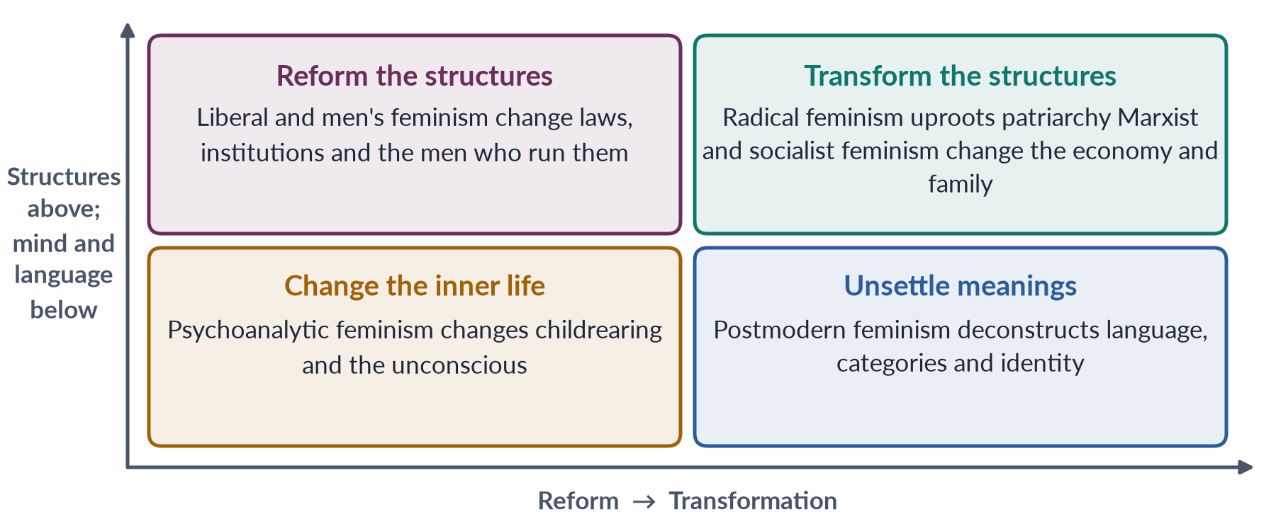
Figure 22 · The schools placed by how much change they want (across) and where they locate the problem (up and down).

9.2 Radical versus socialist feminism (2016)
This is the comparison the examiner asked for directly. Both are "second-wave" schools of the late 1960s and 1970s, and both want deep change rather than reform. They differ on the root cause.
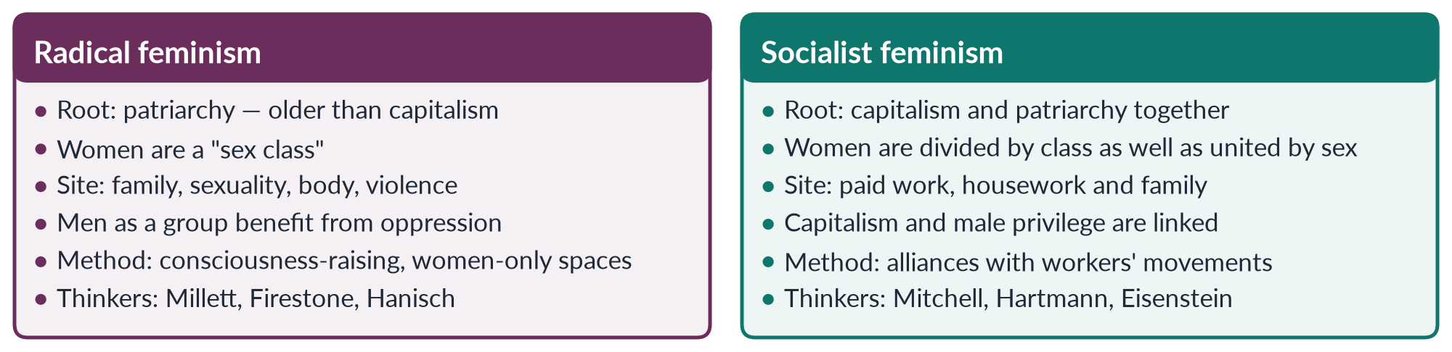
Figure 23 · Radical feminism and socialist feminism.
Table 15 · Radical and socialist feminism point by point.
Point | Radical feminism | Socialist feminism
Main enemy | Patriarchy | Capitalist patriarchy
Unit of analysis | Sex (women as a class) | Sex and class together
Would ending capitalism free women? | No — patriarchy came first and survives in every economy | Not alone — both systems must be changed
View of men | Men as a group are the beneficiaries | Working-class men are also exploited; they can be allies
Key concepts | Sexual politics, sex class, personal is political | Dual systems, family wage, double burden, social reproduction
Typical campaign | Rape crisis centres, shelters, bodily autonomy | Equal pay, childcare, wages for housework, rights of women workers
Main criticism | Ignores class and race; "anti-men" image | Too economic; neglects violence and sexuality

REMEMBER
The one-line difference: radical feminism sees patriarchy alone as the root; socialist feminism sees patriarchy and capitalism working together. They agree that the family is a site of oppression and that "the personal is political".

9.3 Two more comparisons
Table 16 · Liberal versus radical feminism.
Point | Liberal | Radical
Cause | Unequal laws and opportunities | Patriarchy
Strategy | Reform within the system | Transform the system
Sphere | Public — law, work, politics | Private and public — family, body, sexuality
Equality means | Same rights and chances as men | Ending male power in every area
Example law | Equal Pay Act 1963; Harassment Act 2010 (Pakistan) | Laws on rape and domestic violence; shelters

Table 17 · Marxist versus socialist feminism (summary; full detail in Chapter 4).
Point | Marxist | Socialist
Enemy | Capitalism | Capitalism and patriarchy
Gender is | A form of class oppression | Equal in importance to class
Key thinker | Engels (1884) | Hartmann (1979)

9.4 Which feminism suits Pakistan? (2018)

The question and the trap
The question says "type(s)" — the examiner invites you to argue for more than one. The trap is to pick one school and reject the rest, or to write a history of the Pakistani women's movement (that belongs to Topic 3). Instead, match each school to a dimension of status named in the question: socio-cultural, economic and political.

The Pakistani context in five facts
✦ DATA
Women's status in Pakistan · latest figures
• Global Gender Gap Report 2026: Pakistan 143rd of 145, with 59.5% of the gap closed (economic participation 144th, education 130th, political empowerment 107th).
• Female labour-force participation: 24.4% (Labour Force Survey 2024–25).
• Literacy: about 68% men and 53% women (Census 2023).
• Maternal mortality ratio: 186 per 100,000 live births (Pakistan Maternal Mortality Survey 2019).
• Only 11 women won general seats in the National Assembly in 2024; women's presence rests mainly on the 60 reserved seats.

Matching schools to dimensions
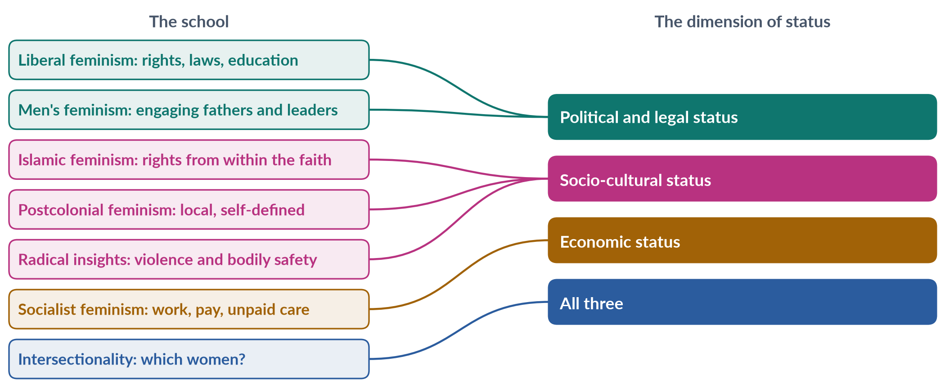
Figure 24 · Which school addresses which dimension of women's status in Pakistan.
1. Liberal feminism — the legal and political floor. It is anchored in Articles 25, 27 and 34 of the Constitution. It gives quotas, anti-harassment and anti-violence laws, and girls' education. Its weakness is enforcement.
2. Islamic (Muslim) feminism — cultural legitimacy. In a society where most people see life through faith, rights argued from the Qur'an — inheritance, mahr, khula, consent, education — meet less resistance. The Federal Shariat Court and superior courts have repeatedly affirmed such rights.
3. Socialist feminism — economic status. Women's low labour participation, unpaid farm and care work, home-based piece work and low wages need economic answers: childcare, safe transport, recognition of unpaid work, labour rights for home-based and domestic workers, and cash transfers such as the Benazir Income Support Programme.
4. Radical insights — safety and bodily integrity. The work against honour killing, acid attacks, rape and domestic violence comes from the radical insight that violence controls women. Pakistan's laws of 2011, 2016 and 2021 reflect it.
5. Men's feminism — the gatekeepers. Fathers, husbands, brothers, clerics and police must be engaged, because they control most decisions about women's lives.
6. Intersectionality — the targeting tool. It ensures that policies reach rural, poor, minority and disabled women and khawaja siras, not only the urban middle class.
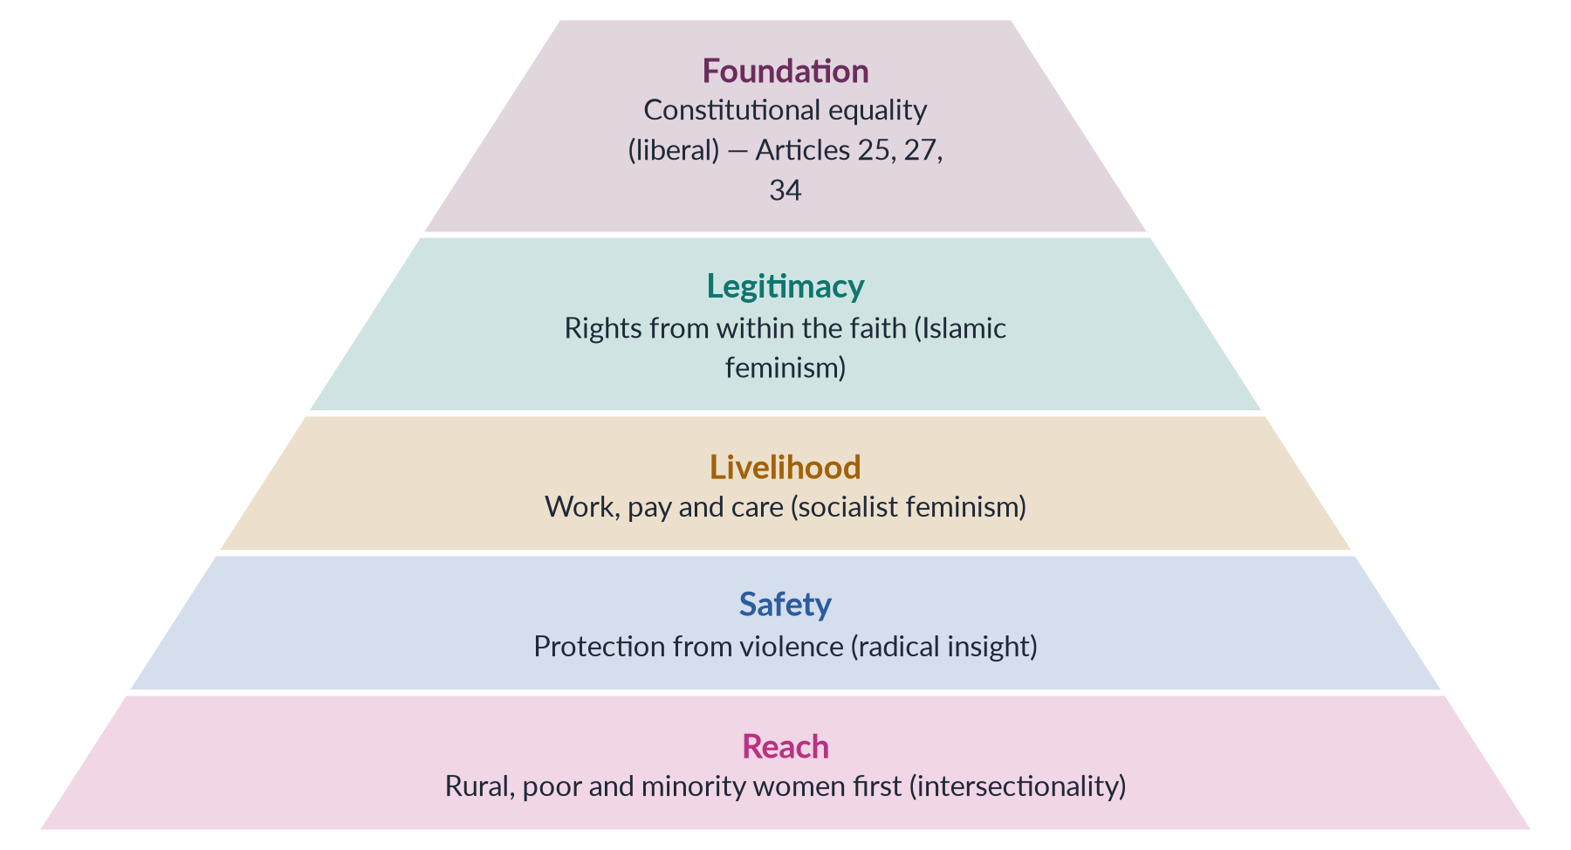
Figure 25 · A layered feminism for Pakistan: from the foundation up.

Which schools fit least — and why they still help
- Pure radical feminism, with separatism and slogans on sexuality, provokes backlash and is easy to paint as foreign. Its analysis of violence is useful; its style is not.
- Pure Marxist feminism waits for a revolution that is not coming; its insights on unpaid work are useful through socialist and welfare policies.
- Postmodern feminism is too abstract for policy, but it warns against speaking of one "Pakistani woman".
- Psychoanalytic feminism gives no quick policy, but its message about shared parenting and raising boys differently is valuable for long-term change.
BALANCED VIEW · THE CONCLUSION TO WRITE
No single imported school can raise women's status in Pakistan. What works is a plural, home-grown feminism: liberal in law, Islamic in cultural justification, socialist in economic policy, radical in its refusal to tolerate violence, inclusive of men, and intersectional in whom it reaches first. This is not a compromise of principles; it is the way Pakistan's own most successful reforms — from the Muslim Family Laws Ordinance of 1961 to the honour-killing law of 2016 — were actually won.

EXAMINER'S EYE · THE MODEL STRUCTURE FOR 2018
1. Introduction: status in three dimensions; Pakistan's gap in figures. 2. What feminism is; why one school is not enough. 3–8. Liberal, Islamic, socialist, radical insight, men's feminism and intersectionality — each with what it offers, a Pakistani law or programme, and its limit. 9. Schools that fit less and what they still offer. 10. The layered model (pyramid figure). 11. Conclusion: a plural, home-grown feminism. A mapping figure of school → dimension earns extra marks.

Part Two — Today's Debates
Theory questions in 2024–2026 increasingly ask you to apply the schools to live issues. These are the debates of Topic 2. Each gives you facts, both sides and a line to take.

Debate 1 · Is feminism a Western import?
HOT DEBATE · "FEMINISM IS A FOREIGN AGENDA"
• The charge: feminism was born in Europe and America, spreads through foreign-funded NGOs, and carries values — individualism, sexual freedom — that clash with Pakistani culture and Islam.
• The reply: the ideas of women's dignity and education appear in South Asian and Muslim writing long before Western influence could explain them — Tarabai Shinde (1882), Mumtaz Ali (1898), Begum Rokeya (1905). Pakistan's own leaders, from the Quaid (1944) to Fatima Jinnah and Benazir Bhutto, spoke for women's rights. Postcolonial feminists themselves criticise Western feminism (Chapter 8).
➜ The line to take: the word came from France; the struggle is universal and has local roots. Pakistan needs feminisms grounded in its Constitution, faith and history — not imported slogans, and not the denial of real problems.

Debate 2 · Islamic feminism: bridge or contradiction?
Covered in Chapter 8. Secular feminists fear that working inside religious texts limits reform; conservatives fear it bends Islam to Western ideas; supporters say it is the most effective route in a Muslim society. Pakistani reforms that lasted — the Muslim Family Laws Ordinance (1961), the Protection of Women Act (2006), the honour-killing amendment (2016) — combined constitutional and Islamic arguments.

Debate 3 · Slogans and strategy: the Aurat March
BALANCED VIEW · "MERA JISM MERI MARZI" AND THE POLITICS OF SLOGANS
Since 2018 the Aurat March has been held on 8 March in major cities. Its slogans on bodily autonomy provoked lawsuits, television quarrels and counter-marches.
• Supporters say the slogan means the right to be free from violence, forced marriage and harassment — a demand every religion and the Constitution (Article 14, dignity of man) supports — and that controversy brought women's issues onto prime-time television.
• Critics say the slogans were open to sexual readings, handed opponents a weapon and alienated potential supporters.
➜ This is the old debate between radical tactics (shock, visibility) and liberal tactics (persuasion within accepted language). A strong answer explains both and notes that the substance — freedom from violence — has broad support.

Debate 4 · Intersectionality in Pakistan: which women?
National averages hide great differences. Female literacy, labour participation and access to health vary sharply between urban and rural areas, between provinces, and between classes. Minority women, women with disabilities and khawaja siras face added barriers (Chapter 8). The debate is whether gender policy should target "women" in general or specific groups at the overlaps. Intersectional analysis — the tool behind the 2025 question and the 2026 question on marginalised women — says both, with priority to those at the overlaps.

Debate 5 · The care economy after COVID-19
LATEST UPDATE · CARE WORK BACK ON THE AGENDA
The COVID-19 pandemic (2020–21) closed schools and increased illness at home, and the extra care fell mainly on women worldwide. This revived the socialist-feminist argument about unpaid care work. SDG target 5.4 asks states to "recognize and value unpaid care and domestic work" through public services, infrastructure and social protection.
➜ In Pakistan the debate covers day-care centres at workplaces, maternity and paternity leave, and whether unpaid work should be counted in national accounts through time-use surveys.

Debate 6 · Fourth-wave digital feminism and the online backlash
- Opportunities: hashtags and social media let women share experiences of harassment across the world. The #MeToo movement spread globally in 2017 (the phrase was first used by the American activist Tarana Burke in 2006). It reached Pakistan in 2018, with harassment allegations in the entertainment industry that led to long defamation cases.
- Risks: online abuse, doxxing, fake images and threats against women journalists, politicians and activists; the growth of anti-feminist "manosphere" content aimed at young men (Chapter 6).
- The line to take: digital space is a new site of both feminist voice and patriarchal control — the Topic 7 material on the Prevention of Electronic Crimes Act 2016 applies here.

Debate 7 · Climate change: ecofeminism or feminist environmentalism?
The 2022 floods affected about 33 million people in Pakistan. Women, especially pregnant women and those in rural Sindh and Balochistan, faced particular risks: lack of privacy in camps, loss of livelihoods, and harassment. The debate is theoretical as well as practical. Ecofeminists link the exploitation of women and nature; feminist environmentalists such as Bina Agarwal trace women's vulnerability to their material work and lack of land rights. The 2026 descriptive paper asked candidates to use both lenses (Topic 4).

Debate 8 · Men as allies — or men's rights?
Programmes engaging men and boys (Rozan, White Ribbon, HeForShe) grow alongside online men's-rights content that blames feminism for men's problems. The debate asks how to reach young men facing unemployment and changing expectations without either blaming them or excusing hostility to women. Men's feminism (Chapter 6) offers the answer researchers favour: positive models of caring manhood, economic opportunity and education on respectful relationships.

Part Three — The Examiner's Record of Topic 2

Every question, 2016–2026
Table 18 · Every question the examiner has set on T2, 2016–2026.
Year · Q | The question (as set) | Family
2016 · Q7 | What is feminism? In what way is Radical Feminism different from Socialist Feminism? | What is feminism; schools of feminism compared; Radical feminism; Marxist / socialist feminism
2018 · Q4 | What type(s) of feminism can elevate the socio-cultural, economic and political status of women in Pakistan? | Which feminism suits Pakistan
2019 · Q8(b) | Short note: Postmodern Feminism | Postmodern feminism
2021 · Q4 | Marxist feminism is a philosophical variant of feminism that incorporates and extends Marxist theory and analyzes the ways in which women are exploited through capitalism and the individual ownership of private property. Discuss the development of Marxist/Socialist feminism and the philosophical stance it holds on gender issues and exploitation. | Marxist / socialist feminism
2021 · Q5 | Psychoanalytic feminism is a theory of oppression which asserts that men have an inherent psychological need to subjugate women. Give a detailed analysis of gender oppression and women's subordination promulgated by Psychoanalytic Feminism. | Psychoanalytic feminism
2022 · Q3 | Describe any two Western schools of thought about feminism in detail. | What is feminism; schools of feminism compared
2024 · Q8(b) | Short note: Radical Feminism | Radical feminism
2025 · Q6 | Give a detailed analysis of the intersectionality of gender with other social identities. | Intersectionality

What the record reveals
- Six full questions and two short notes in eleven papers — the lightest topic in the descriptive paper, but the second-richest source of MCQs (26 of 140).
- Every syllabus school except men's feminism has been asked. Radical (2016, 2024), Marxist/socialist (2016, 2021), psychoanalytic (2021), postmodern (2019) and "any two schools" (2022). Liberal feminism has appeared only inside comparisons and the 2023 MCQ — and men's feminism never. Both are due.
- The questions quote their own definitions. 2021 printed a full definition of Marxist feminism and a (questionable) one of psychoanalytic feminism. Use the question's words in your introduction, and correct them politely where needed.
- The applied question. 2018 asked which feminism(s) suit Pakistan. The examiner values application — expect it again, perhaps as "Is feminism relevant to Pakistan?" or "Can Islamic feminism improve women's status?"
- The move beyond the syllabus. Intersectionality (2025 essay; 2024 MCQ; 2026 question on marginalised women), standpoint, kyriarchy, the matrix of domination and the patriarchal bargain (2026 MCQs) show the examiner now reads newer theory. Chapter 8 matters as much as the syllabus chapters.
- MCQs repeat. The Second Sex (2016, 2019, 2025), The Feminine Mystique (2024, 2025), Kate Millett (2016, 2023) and post-structural feminism (2018, 2023) have each come at least twice.

Five likely questions
1. "Critically evaluate liberal feminism. Can legal reforms alone improve the status of women in Pakistan?" (Chapter 2, with Chapter 9.)
2. "What is men's feminism? Discuss the role of men in achieving gender equality, with reference to Pakistan." (Chapter 6 — the only syllabus school never asked.)
3. "Is Islamic feminism a viable framework for women's empowerment in Pakistan? Discuss." (Chapters 8 and 9.)
4. "Compare and contrast liberal and radical feminism. Which is more relevant to Pakistan?" (Chapters 2, 3 and 9.)
5. "Discuss standpoint theory and intersectionality as contributions of Black feminism to feminist thought." (Chapter 8.)
These are not solved here; the Prediction Papers include answers to predicted questions. Plan each as an answer map for practice.

Part Four — The One-Liner Bank
About 120 one-liners in the style of the past MCQs. Each is a complete, checkable fact: the key word is in bold green and the date in bold navy. Read them aloud; cover the bold words and test yourself; then attempt every past MCQ below.

The one-liners

A · What feminism is
1. Feminism is the belief in equal rights and chances for women and men, together with action to achieve it — both a theory and a practice.
2. Feminist perspectives are distinctive because they emphasise the centrality of gender (MCQ 2025).
3. Kamla Bhasin and Nighat Said Khan (1986) defined feminism as "an awareness of women's oppression and exploitation in society, at work and within the family, and conscious action by women and men to change this situation".
4. bell hooks (Feminism Is for Everybody, 2000): feminism is "a movement to end sexism, sexist exploitation, and oppression".
5. Rebecca West (1913) said people called her a feminist whenever she refused to be treated as "a doormat or a prostitute".
6. The word féminisme began in France; Hubertine Auclert called herself a feminist in 1882.
7. The "wave" metaphor was popularised by Martha Weinman Lear in 1968 ("The Second Feminist Wave").
8. The Seneca Falls Convention (New York, 1848) is taken as the start of first-wave feminism.
9. Rebecca Walker announced a "Third Wave" in 1992; the fourth wave (from about 2012) is digital.
10. Tarabai Shinde wrote Stri Purush Tulana (1882), an early South Asian attack on double standards.
11. Begum Rokeya Sakhawat Hossain wrote Sultana's Dream (1905), imagining a "Ladyland" run by women.
12. The Second Sex (1949) was written by Simone de Beauvoir (MCQs 2016, 2019, 2025).
13. The Quaid-e-Azam said at Aligarh (1944): "No nation can rise to the height of glory unless your women are side by side with you."

B · Liberal feminism
14. The theory that men and women should be treated equally is liberal feminism (MCQ 2023).
15. Liberal feminism rests on Enlightenment liberalism: individuals have reason and natural rights.
16. Its remedy is reform within the system — equal laws, education and opportunity — not revolution.
17. Mary Wollstonecraft wrote A Vindication of the Rights of Woman (1792), answering Rousseau's Émile (1762).
18. Wollstonecraft argued that women seem weak because they are denied a rational education.
19. Olympe de Gouges wrote the Declaration of the Rights of Woman and of the Female Citizen (1791).
20. Elizabeth Cady Stanton and Lucretia Mott drafted the Declaration of Sentiments at Seneca Falls (1848).
21. John Stuart Mill wrote The Subjection of Women (1869), influenced by Harriet Taylor Mill.
22. Mill proposed in 1867 to replace "man" with "person" in the Reform Bill to give women the vote.
23. Betty Friedan wrote The Feminine Mystique (1963) (MCQs 2024, 2025) — "the problem that has no name".
24. Friedan co-founded the National Organization for Women (NOW) in 1966.
25. Susan Moller Okin (Justice, Gender, and the Family, 1989) argued the family itself must be just.
26. Martha Nussbaum (2000) applied the capabilities approach to women's development.
27. The main criticism of liberal feminism: it ignores structures and the private sphere, and speaks for middle-class women.

C · Radical feminism
28. "Radical" comes from Latin radix, "root": patriarchy is the root of oppression.
29. Replacing patriarchy is a radical idea (MCQ 2019).
30. Kate Millett was a radical feminist (MCQs 2016, 2023); she wrote Sexual Politics (1970).
31. Millett defined "sexual politics" as power relations between the sexes and made "patriarchy" the key concept.
32. The Dialectic of Sex (1970) was written by Shulamith Firestone (MCQ 2016).
33. Firestone called women a "sex class" and located oppression in reproduction.
34. "The personal is political" is the title of Carol Hanisch's essay (written 1969, published 1970).
35. Consciousness-raising groups turned "personal" problems into shared political awareness.
36. Redstockings (1969) declared: "Women are an oppressed class."
37. Susan Brownmiller (Against Our Will, 1975) described rape as a tool that keeps all women in fear.
38. Catharine MacKinnon (1979) argued that sexual harassment is sex discrimination.
39. Adrienne Rich wrote "Compulsory Heterosexuality and Lesbian Existence" (1980).
40. Tong divides radical feminists into radical-libertarian (Firestone) and radical-cultural (Daly, Rich).
41. The first modern women's shelter opened in Chiswick, London, in 1971 — a radical-feminist legacy.
42. "Mera Jism Meri Marzi" ("My body, my choice") of the Aurat March (from 2018) echoes radical feminism's demand for bodily autonomy.

D · Marxist and socialist feminism
43. Marxist feminism traces women's oppression to capitalism and private property.
44. Friedrich Engels wrote The Origin of the Family, Private Property and the State (1884).
45. Engels called the rise of private property and father-right "the world historical defeat of the female sex".
46. Engels drew on Lewis Henry Morgan's Ancient Society (1877).
47. August Bebel wrote Woman and Socialism (1879).
48. Clara Zetkin proposed International Women's Day at Copenhagen in 1910; the UN began marking it on 8 March in 1975.
49. Alexandra Kollontai pushed for communal kitchens and childcare in the Soviet Union.
50. Margaret Benston (1969) argued that unpaid housework is real production.
51. Dalla Costa and Selma James (1972) said housework produces the key commodity — the worker; this led to Wages for Housework (1972).
52. Silvia Federici (1975): "They say it is love. We say it is unwaged work."
53. Social reproduction means the unpaid daily and generational work that keeps workers alive and able to work.
54. The reserve army of labour is a pool of workers — often women — hired in booms and dropped in slumps.
55. Socialist feminism holds that capitalism and patriarchy together oppress women.
56. Juliet Mitchell (Woman's Estate, 1971) named four structures: production, reproduction, sexuality and socialisation of children.
57. Heidi Hartmann wrote "The Unhappy Marriage of Marxism and Feminism" (1979) — dual-systems theory.
58. Hartmann called Marxism "sex-blind" and cited the male "family wage" as capitalism and patriarchy working together.
59. Zillah Eisenstein (1979) coined "capitalist patriarchy"; Iris Marion Young (1980) proposed unified-systems theory.
60. Maria Mies (1986) described the "housewifisation" of women's work worldwide.
61. Sylvia Walby (1990) named six structures of patriarchy: paid work, household production, culture, sexuality, violence and the state.
62. Arlie Hochschild (1989) named the "second shift" — housework after paid work.
63. Pakistan's Lady Health Worker Programme began in 1994; Sindh passed the first Home-Based Workers Act in 2018.

E · Psychoanalytic feminism
64. Psychoanalytic feminism roots women's oppression in the unconscious and early childhood.
65. Sigmund Freud said "Anatomy is destiny" (1924), adapting a phrase of Napoleon.
66. Freud's Oedipus complex: the boy identifies with the father; the girl develops penis envy (1925).
67. Freud claimed women have a weaker superego (conscience).
68. Karen Horney ("The Flight from Womanhood", 1926) proposed womb envy — men envy women's power to give birth.
69. Horney said girls envy men's social power, not the penis itself.
70. Juliet Mitchell (Psychoanalysis and Feminism, 1974): Freud described patriarchy; he did not recommend it.
71. Dorothy Dinnerstein (The Mermaid and the Minotaur, 1976) linked male domination to fear of the all-powerful mother.
72. Nancy Chodorow (The Reproduction of Mothering, 1978): girls develop relational selves, boys separate — so mothering reproduces gender.
73. Chodorow's and Dinnerstein's remedy is shared (dual) parenting.
74. Carol Gilligan (In a Different Voice, 1982) contrasted the ethic of care with Kohlberg's ethic of justice.
75. Jacques Lacan placed the child's entry into language under the "Law of the Father" — the symbolic order.
76. Luce Irigaray wrote Speculum of the Other Woman (1974) and This Sex Which Is Not One (1977).
77. Julia Kristeva contrasted the maternal semiotic with the paternal symbolic (1974).
78. Hélène Cixous presented écriture féminine in "The Laugh of the Medusa" (1975) (MCQ 2024).

F · Men's feminism
79. Men's feminism (pro-feminism) is men's support for gender equality and analysis of how patriarchy harms men too.
80. Frederick Douglass was the only African-American to sign the Seneca Falls Declaration of Sentiments (1848).
81. Condorcet wrote On the Admission of Women to the Rights of Citizenship (1790).
82. Sayyid Mumtaz Ali of Lahore wrote Huquq-un-Niswan (1898); Qasim Amin wrote The Liberation of Women (1899).
83. R. W. Connell (Masculinities, 1995) named the patriarchal dividend — men's gain from women's subordination.
84. Michael Kimmel described manhood as a test performed before other men (Manhood in America, 1996).
85. bell hooks (The Will to Change, 2004) argued patriarchy wounds men emotionally.
86. The White Ribbon Campaign began in Canada in 1991, after the Montreal massacre of 1989.
87. UN Women launched HeForShe on 20 September 2014 (Emma Watson's speech).
88. The MenEngage Alliance (2004) is a global network working with men and boys.
89. Robert Bly's Iron John (1990) led the mythopoetic men's movement; men's rights groups are generally anti-feminist.

G · Postmodern and post-structural feminism
90. Post-structural feminism emphasises the contingent and discursive nature of identities (MCQs 2018, 2023).
91. Contingent = not fixed, could be otherwise; discursive = made by language and discourse.
92. Gender equality constructed through literature is associated with postmodern feminism (MCQ 2019).
93. Lyotard (The Postmodern Condition, 1979) defined the postmodern as "incredulity toward metanarratives".
94. Derrida's deconstruction (1967) unsettles ranked binaries such as man/woman.
95. Foucault joined power and knowledge: discourses define what is "normal".
96. Postmodern feminism holds there is no universal "woman" — the stance called anti-essentialism.
97. Judith Butler (Gender Trouble, 1990): gender is performative.
98. Jane Flax (1987) and Joan Scott (1986, 1988) were early postmodern feminist writers; Scott deconstructed equality versus difference.
99. Donna Haraway wrote "A Cyborg Manifesto" (1985).
100. Seyla Benhabib (1995) warned that the "death of the subject" leaves no one to act.
101. Martha Nussbaum attacked Butler in "The Professor of Parody" (1999).
102. Strategic essentialism (Spivak) means temporary strategic unity around an identity (MCQ 2026).
103. Kishwar Naheed's poem "We Sinful Women" became an anthem of Pakistan's 1980s women's movement.

H · Black feminism, intersectionality and standpoint
104. Sojourner Truth's "Ain't I a Woman?" speech was given at Akron, Ohio, in 1851.
105. The Combahee River Collective (1977) described interlocking oppressions experienced simultaneously.
106. Black feminism focuses on race, class and gender together — "all of these" (MCQ 2025).
107. Kimberlé Crenshaw coined intersectionality in 1989 ("Demarginalizing the Intersection of Race and Sex").
108. Intersectionality originated from discussions on gender and race (MCQ 2024).
109. Crenshaw's example was DeGraffenreid v. General Motors (1976), where Black women fell between race and sex claims.
110. Patricia Hill Collins developed the matrix of domination (Black Feminist Thought, 1990) (MCQ 2026).
111. Alice Walker coined womanism (1983); Audre Lorde wrote "The Master's Tools Will Never Dismantle the Master's House".
112. Standpoint theory argues that knowledge is socially situated (MCQ 2026).
113. Nancy Hartsock ("The Feminist Standpoint", 1983), Sandra Harding ("strong objectivity") and Dorothy Smith are standpoint theorists.

I · Postcolonial, eco- and Muslim feminism, and other terms
114. Chandra Talpade Mohanty ("Under Western Eyes", 1984) criticised the Western image of a single "Third World Woman".
115. Gayatri Spivak ("Can the Subaltern Speak?", 1988): "White men are saving brown women from brown men."
116. Françoise d'Eaubonne coined ecofeminism in 1974.
117. Vandana Shiva wrote Staying Alive (1988); the Chipko tree-hugging movement began in 1973.
118. Bina Agarwal (1992) proposed feminist environmentalism: women's link to nature comes from their material work, not biology.
119. Amina Wadud wrote Qur'an and Woman (1992); Fatima Mernissi wrote The Veil and the Male Elite (1987).
120. Asma Barlas ("Believing Women" in Islam, 2002) and Riffat Hassan are Pakistani-born Muslim feminist scholars.
121. Musawah, a global movement for equality in Muslim family law, was launched in 2009.
122. The patriarchal bargain was elaborated by Deniz Kandiyoti ("Bargaining with Patriarchy", 1988) (MCQs 2026).
123. Elisabeth Schüssler Fiorenza coined kyriarchy (1992) to describe interlocking structures of domination (MCQ 2026).
124. Elaine Showalter coined gynocriticism (1979) — the study of women writers (MCQ 2024).

J · Comparisons and Pakistan
125. Radical feminism: patriarchy alone is the root; socialist feminism: patriarchy and capitalism together.
126. Liberal feminism reforms the system; radical and Marxist feminism seek to transform it.
127. Pakistan's Constitution guarantees non-discrimination on the basis of sex in Article 25, and women's full participation in Article 34.
128. The best answer to "Which feminism suits Pakistan?" is a plural blend: liberal law, Islamic legitimacy, socialist economics, radical vigilance on violence, men as allies, and intersectional targeting.

Every past MCQ on Topic 2
Table 19 · Every recovered MCQ on T2, with its key.
Year | Question | Key
2016 · 2 | The Second Sex was written by: | D - Simone de Beauvoir
2016 · 4 | The Dialectic of Sex was written by: | B - Shulamith Firestone
2016 · 12 | Kate Millett was a: | A - Radical feminist
2018 · 4 | Post-structural feminism emphasizes: | B - The contingent and discursive nature of all identities
2019 · 5 | Gender equality constructed through literature is associated here with: | A - Postmodern Feminism
2019 · 6 | Replacing patriarchy is a: | A - Radical idea
2019 · 17 | The Second Sex was written by: | D - Simone de Beauvoir
2023 · 10 | Post-structural feminism focuses on: | B - The contingent and discursive nature of identities
2023 · 12 | Kate Millett was a: | C - Radical feminist
2023 · 20 | The theory that men and women should be treated equally is often called: | A - Liberal feminism
2024 · 1 | Who presented the term ecriture feminine, describing the female experience of writing? | B - Helene Cixous
2024 · 5 | Intersectionality originated from discussions on: | A - Gender and race
2024 · 6 | Elaine Showalter coined: | C - Gynocriticism
2024 · 18 | The Feminine Mystique was written by: | C - Betty Friedan
2025 · 1 | Feminist perspectives are distinctive because: | A - They emphasize the centrality of gender
2025 · 3 | Which has not been central to feminist theorizing? | No fully valid option - all three have been central in feminist scholarship
2025 · 5 | A feminist perspective emphasizing the value of women's personal experiences: | D - Postmodern feminism (suggested key)
2025 · 8 | The Feminine Mystique was authored by: | B - Betty Friedan
2025 · 9 | Black feminism differs from mainstream feminism through its focus on: | D - All of these
2025 · 10 | Who wrote The Second Sex? | D - Simone de Beauvoir
2026 · 5 | The concept of 'patriarchal bargain' was elaborated by: | A - Deniz Kandiyoti
2026 · 9 | Strategic essentialism suggests that: | B - Temporary strategic unity around an identity
2026 · 10 | Standpoint Theory argues that: | C - Knowledge is socially situated
2026 · 11 | Elisabeth Schussler Fiorenza coined kyriarchy to describe: | B - Interlocking structures of domination
2026 · 14 | 'Bargaining with Patriarchy' was coined by: | D - None of these; Deniz Kandiyoti
2026 · 20 | The Matrix of Domination was developed by: | D - None of these; Patricia Hill Collins

TRAP · THREE MCQ TRAPS IN TOPIC 2
1. Two "Mitchells", one idea each. Juliet Mitchell wrote both Woman's Estate (socialist feminism, 1971) and Psychoanalysis and Feminism (1974). Check which book the question names.
2. "Coined" versus "developed". Crenshaw coined intersectionality (1989); Collins developed the matrix of domination (1990); Kandiyoti coined the patriarchal bargain (1988); Schüssler Fiorenza coined kyriarchy (1992).
3. "None of these" is sometimes right. Two 2026 MCQs (Kandiyoti; Collins) had no correct option among A–C. If the name you know is missing, choose "none of these".

Part Five — The Revision Sheet
The whole of Topic 2 in a few pages, for the night before the exam. Every term is explained where it appears, so you will not need to turn back to the chapters.

1. What feminism is
- Feminism — the belief that women and men should have equal rights, dignity and chances, plus the action to achieve it. Two parts: a theory (explains why women are disadvantaged) and a practice (a movement to change it). Hence the syllabus head "Feminist Theories and Practice".
- Definitions to quote:
- Kamla Bhasin and Nighat Said Khan (1986) — "an awareness of women's oppression and exploitation in society, at work and within the family, and conscious action by women and men to change this situation." (South Asian; names three sites; includes men.)
- bell hooks (2000) — "a movement to end sexism (unfair treatment because of sex), sexist exploitation, and oppression." (Targets sexism, not men.)
- Rebecca West (1913) — called a feminist whenever she refused to be "a doormat or a prostitute".
- Feminist perspective — puts gender at the centre of analysis (MCQ 2025): always asks "how are women and men affected differently, and why?"
- The word — French féminisme; Hubertine Auclert used "feminist" in 1882; reached English in the 1890s. The ideas are much older.
- Waves (a metaphor made popular by Martha Weinman Lear, 1968) — first (c. 1848–1920: vote, property, education; Seneca Falls 1848); second (1960s–80s: family, work, body, sexuality); third (1990s: diversity; Rebecca Walker 1992); fourth (c. 2012 on: digital; #MeToo 2017). Waves follow Western history — a map, not a law. (Full history is Topic 3.)
- Common ground of all schools — (1) women are disadvantaged; (2) it is made by society, not nature; (3) the personal and political are linked; (4) women's experience counts as knowledge; (5) change is possible. They disagree on cause, site (where) and cure.
- South Asian and Muslim roots — Tarabai Shinde, Stri Purush Tulana (1882); Sayyid Mumtaz Ali, Huquq-un-Niswan (Lahore, 1898, rights from the Qur'an); Qasim Amin, The Liberation of Women (Egypt, 1899); Begum Rokeya, Sultana's Dream (1905); APWA (1949, Begum Ra'ana Liaquat Ali Khan); WAF (1981). Quaid-e-Azam, Aligarh 1944: "No nation can rise to the height of glory unless your women are side by side with you."
- Myths — not man-hating (targets sexism); not one ideology (a family of theories); not only Western; not always anti-religion (Muslim feminism); not "women becoming men"; not outdated (Pakistan 143rd of 145, Global Gender Gap Report 2026; women's labour-force participation 24.4%, LFS 2024–25).
- The four questions that separate the schools — cause (why?), site (law, family, economy, mind, language?), remedy (reform or transform?), method (laws, protest, revolution, therapy, new language?).

2. Liberal feminism
- Definition — women are as rational as men; their disadvantage comes from unequal laws, customs and opportunities; remedy = reform (equal rights, education, work, political access) within the existing system. MCQ 2023: "men and women should be treated equally" = liberal feminism.
- Roots — liberalism of the Enlightenment: the individual, reason, natural rights, equal citizenship.
- First wave:
- Mary Wollstonecraft, A Vindication of the Rights of Woman (1792) — answered Rousseau's Émile (1762), which said girls should be educated to please men; women seem weak because denied a rational education.
- Olympe de Gouges, Declaration of the Rights of Woman and of the Female Citizen (1791); executed 1793.
- Seneca Falls (1848) — Stanton and Mott's Declaration of Sentiments: "all men and women are created equal".
- J. S. Mill, The Subjection of Women (1869), with Harriet Taylor Mill (The Enfranchisement of Women, 1851) — legal subordination of women is wrong and blocks progress; women's "nature" is "an eminently artificial thing"; 1867 motion to replace "man" with "person".
- Vote: New Zealand 1893; USA 1920; Britain 1918 (partial), 1928 (equal).
- Second wave:
- Betty Friedan, The Feminine Mystique (1963) — "the problem that has no name": unhappiness of educated housewives; the "mystique" = belief that women are fulfilled only as wives and mothers. Co-founded NOW (1966).
- US Equal Pay Act (1963); Title VII, Civil Rights Act (1964, no sex discrimination in jobs); CEDAW (UN women's-rights treaty, 1979; Pakistan joined 1996).
- Later — Susan Moller Okin (1989): the family must be just; Martha Nussbaum (2000): capabilities approach (real freedom to be and do — health, education, safety, work); Zillah Eisenstein (1981).
- Strengths — won the vote, education, equal-pay and anti-discrimination laws; persuasive rights language; practical, works through courts and parliaments; fits CEDAW and SDG 5.
- Criticisms — ignores structures and unpaid care; keeps the state out of the private sphere (family); equality = sameness with a male norm; middle-class bias (hooks on Friedan); individualism.
- Pakistan — Article 25 (equality; no sex discrimination; special provision for women allowed), Article 27 (no sex discrimination in public service), Article 34 (full participation of women); laws of 2006 (Protection of Women), 2010 (workplace harassment), 2016 (honour killing), 2021 (anti-rape), ICT Child Marriage Restraint Act 2025 (age 18); 60 reserved seats; NCSW (2000); Malala (Nobel 2014). Limit: weak enforcement, poverty and custom.

3. Radical feminism
- Definition — "radical" from Latin radix = root. Patriarchy (male power over women) is the oldest, deepest oppression, present everywhere — especially in family, sexuality, body and violence. Remedy: transform society at the root. MCQ 2019: replacing patriarchy = a radical idea.
- Origin — USA, late 1960s; women in civil-rights and anti-war "New Left" movements were sidelined by male comrades. New York Radical Women (1967; Miss America protest 1968 — "freedom trash can", no bras actually burned); Redstockings (1969): "Women are an oppressed class."
- "The personal is political" — Carol Hanisch (written 1969, published 1970): private problems (housework, sex, marriage) are political — shared, and caused by power. Consciousness-raising = small groups sharing experiences to reach political awareness.
- Thinkers:
- Kate Millett, Sexual Politics (1970) — sexual politics = power relations between the sexes; made patriarchy the key concept; found it in family, religion, literature, force. MCQs 2016, 2023: Millett = radical feminist.
- Shulamith Firestone, The Dialectic of Sex (1970, MCQ 2016) — root in biology/reproduction; women a "sex class"; seize control of reproduction; imagined artificial reproduction.
- Robin Morgan, Sisterhood Is Powerful (1970); Susan Brownmiller, Against Our Will (1975) — rape keeps all women in fear; Mary Daly, Gyn/Ecology (1978); Adrienne Rich, Of Woman Born (1976), "Compulsory Heterosexuality" (1980); Catharine MacKinnon (1979) — sexual harassment = sex discrimination; with Andrea Dworkin, anti-pornography campaign (1983).
- Two kinds (Rosemarie Tong) — radical-libertarian (femininity is a trap; aim androgyny; Firestone) vs radical-cultural (female values are better; celebrate the female; Daly, Rich).
- Achievements — rape crisis centres; women's shelters (first modern one, Chiswick, London, 1971); domestic violence made a public crime; sexual harassment law; marital rape recognised; bodily autonomy (right to decide about one's own body).
- Criticisms — treats all women as one (ignores race, class — hooks, Lorde); biological determinism (Firestone); anti-men image; patriarchy too universal to explain change; divisive "sex wars" (1980s splits over pornography); backlash in conservative societies.
- Pakistan — WAF (1981) against the Hudood Ordinances (1979, rape victims at risk of adultery charges); laws on harassment (2010), acid (2011), honour killing (2016), rape (2021); Aurat March (from 8 March 2018) slogan Mera Jism Meri Marzi ("My body, my choice") = bodily autonomy; controversy 2019–20. Line: radical analysis of violence is powerful; argue it in constitutional and Islamic language.

4. Marxist and socialist feminism
- Marxist terms — capitalism (few own the means of production; most sell labour); class (owners/bourgeoisie vs workers/proletariat); exploitation (workers paid less than the value they produce — profit); base/superstructure (economy shapes law, family, ideas); reserve army of labour (workers hired in booms, dropped in slumps).
- Marxist feminism — oppression rooted in capitalism and private property; women exploited as unpaid domestic workers and as a cheap reserve army; gender oppression = form of class oppression; ends when capitalism ends.
- Classical:
- Engels, The Origin of the Family, Private Property and the State (1884) — private property → men want heirs → monogamy imposed on women → "world historical defeat of the female sex"; based on Lewis Henry Morgan, Ancient Society (1877). Cure: end private property; women into paid work.
- August Bebel, Woman and Socialism (1879); Clara Zetkin — proposed International Women's Day, Copenhagen 1910 (first held 1911; UN from 1975, 8 March); Alexandra Kollontai — Soviet communal kitchens and childcare.
- Domestic-labour debate — Margaret Benston (1969): housework is real production; Dalla Costa and Selma James (1972): housework produces the worker; Wages for Housework (1972); Silvia Federici (1975): "They say it is love. We say it is unwaged work." Social reproduction = unpaid work that keeps people alive and able to work (cooking, cleaning, childcare, care of sick and old) — Lise Vogel (1983), Tithi Bhattacharya (2017).
- Socialist feminism — capitalism and patriarchy together; studies paid and unpaid work, class and gender; change economy and family.
- Juliet Mitchell — "Women: The Longest Revolution" (1966), Woman's Estate (1971): four structures — production, reproduction, sexuality, socialisation of children.
- Heidi Hartmann, "The Unhappy Marriage of Marxism and Feminism" (1979) — Marxism "sex-blind"; dual systems (capitalism + patriarchy); male unions' family wage pushed women home.
- Zillah Eisenstein (1979) — "capitalist patriarchy"; Iris Marion Young (1980) — unified systems; Maria Mies (1986) — "housewifisation" (women's work everywhere treated as secondary and cheap); Sylvia Walby (1990) — six structures of patriarchy (paid work, household production, culture, sexuality, violence, state).
- Stance — materialism; two exploitations (paid and unpaid); double burden / "second shift" (Hochschild, 1989); family serves capital; women as reserve army; liberation needs economic independence and socialised care (public childcare, paid leave).
- Criticisms — sex-blind; reduces gender to economics; underplays violence and sexuality; socialist states left women a double burden; wages for housework may fix women at home; dual systems hard to link.
- Pakistan — most employed women in agriculture, much as unpaid family helpers; home-based workers (Sindh Act 2018, first); Lady Health Worker Programme (1994; Supreme Court regularisation order 2012); Sindhiani Tehreek (from 1982, rural Sindhi women); Okara tenants' movement (from 2000, women's groups); BISP (2008, cash to women); Women Democratic Front (2018).

5. Psychoanalytic feminism
- Definition — oppression rooted in the psyche (mind): the unconscious (hidden desires and fears) and early childhood in the family produce "masculine" and "feminine" personalities; change needs new childrearing and new cultural meanings.
- Freud — Oedipus complex (age 3–5): boy desires mother, fears castration, identifies with father → strong superego (conscience); girl discovers "lack", penis envy, turns to father, wants a baby (son) → weaker superego (1925); "Anatomy is destiny" (1924); "Femininity" (1933).
- The attack — Karen Horney, "The Flight from Womanhood" (1926): girls envy men's social power, not the penis; womb envy — men envy women's power to give birth and compensate by achievement and domination; Clara Thompson (1940s): envy of cultural privilege; Beauvoir (1949): body's meaning is social; Friedan (1963), Millett (1970) blamed Freud for keeping women home.
- The re-reading — Juliet Mitchell, Psychoanalysis and Feminism (1974): psychoanalysis is "not a recommendation for a patriarchal society, but an analysis of one."
- Object-relations (mothering) — Dorothy Dinnerstein, The Mermaid and the Minotaur (1976): women alone care for infants → adults fear female power → control women; remedy: shared parenting. Nancy Chodorow, The Reproduction of Mothering (1978): girls stay close to mother → relational self, wish to care; boys separate → masculinity as "not-mother", devalue the feminine; mothering reproduces gender; remedy: dual parenting. Carol Gilligan, In a Different Voice (1982): ethic of care (relationships) vs Kohlberg's ethic of justice (rules, rights).
- Lacan and the French — Lacan: entry into language (symbolic order) under the "Law of the Father"; phallus = symbol of power, not organ. Irigaray (Speculum, 1974; This Sex Which Is Not One, 1977) — woman only a mirror for man; Kristeva (1974) — maternal semiotic (rhythm, feeling) disturbs paternal symbolic; Cixous, "The Laugh of the Medusa" (1975) — écriture féminine ("feminine writing" from the body; MCQ 2024).
- How it explains subordination — men's fear and envy; masculinity built by rejecting the mother; femininity as self-sacrifice; mothering repeats; culture male-centred; oppression internalised (women accept or defend it).
- Correct the 2021 wording — men's need to dominate is deep and unconscious but produced, not "inherent" — so it can change.
- Criticisms — untestable; assumes Western nuclear family; ignores money, law, violence; mother-blaming; heteronormative (assumes mother–father family); abstract.
- Pakistan — son preference; boys moved to male spaces and taught not to cry; mother–son bond and mother-in-law power (Kandiyoti's patriarchal bargain); internalised limits on mobility; value of fathers in childcare and paternity leave.

6. Men's feminism
- Definition — men's support for gender equality (pro-feminism) and analysis of how patriarchy shapes and harms men; aims to change masculinity and male-run institutions.
- History — Condorcet (1790); Raja Ram Mohan Roy (against sati, banned 1829); Frederick Douglass (only African-American signer at Seneca Falls, 1848); Vidyasagar (Widows' Remarriage Act 1856); Mill (1869); Mumtaz Ali (1898); Qasim Amin (1899); Sheikh Abdullah "Papa Mian" (girls' school, Aligarh, 1906); Jinnah (1944).
- Thinkers — R. W. Connell, Masculinities (1995): hegemonic masculinity (the honoured, dominant ideal of manhood) and patriarchal dividend (advantage all men gain); Michael Kimmel (1996, 2008): manhood proved before other men; Michael Messner (1997): men's movements mapped by privilege, costs, differences; bell hooks, The Will to Change (2004): patriarchy wounds men emotionally; Michael Flood: violence prevention with men.
- Men's movements — pro-feminist (NOMAS); men's liberation (1970s, costs of male role); mythopoetic (Robert Bly, Iron John, 1990); men's rights (anti-feminist: custody, "false accusations").
- Campaigns — Montreal massacre (6 Dec 1989, 14 women killed) → White Ribbon (Canada, 1991; pledge never to commit, excuse or stay silent about violence against women); ICPD Cairo 1994 (male responsibility); Beijing 1995; MenEngage (2004); HeForShe (UN Women, 20 Sept 2014, Emma Watson).
- Costs of patriarchy for men — shorter lives; higher suicide; most homicide victims; provider burden (in Pakistan: dowries, migration, debt); distant fatherhood.
- Debate: can men be feminists? — yes (hooks: against sexism, not men); yes as allies, not leaders; caution (image-seeking, diverted funds); no (few radicals). Accepted view: pro-feminist allies, accountable to women.
- Pakistan — decisions on girls' school, marriage, work, inheritance made by fathers, brothers, husbands, elders → engage them; Rozan (Islamabad; boys, men, police); Ziauddin Yousafzai (Let Her Fly, 2018); male scholars on inheritance and consent.
- Criticisms — centres men; privilege remains; slides into men's rights; men dominate spaces; weak evidence of lasting behaviour change.

7. Postmodern and post-structural feminism
- Definition — no universal "woman"; no single cause or truth; identities are constructed in language and discourse, multiple and unstable; task: deconstruct binaries (man/woman, reason/emotion) and value plurality and difference.
- MCQ key — post-structural feminism emphasises "the contingent and discursive nature of identities" (2018, 2023). Contingent = not fixed, could be otherwise. Discursive = made by discourse (how society talks and thinks about something, and who may speak).
- Roots — Lyotard, The Postmodern Condition (1979): "incredulity toward metanarratives" (disbelief in grand stories like progress or class revolution); Derrida (1967): deconstruction of ranked opposites; Foucault (1975, 1976): power/knowledge, discourses define "normal". Structuralism = fixed structures of meaning; post-structuralism = meaning never fixed.
- Core ideas — anti-essentialism; difference among women; language constructs reality; suspicion of grand theories; value of local and personal knowledge (MCQ 2025, women's personal experiences → postmodern, suggested key).
- Thinkers — Butler, Gender Trouble (1990): gender performative (repeated acts create it); Bodies That Matter (1993); Cixous, Irigaray, Kristeva (French feminism, écriture féminine) — explains MCQ 2019: gender equality through literature = postmodern feminism; Jane Flax (1987); Joan Scott (1986; 1988, equality vs difference a false binary); Donna Haraway, "A Cyborg Manifesto" (1985); Chris Weedon (1987); Fraser and Nicholson (1988, middle way).
- Modern vs postmodern — one "women" vs many womanhoods; one main cause vs many forms of power; universal truths vs local truths; one path vs plural struggles.
- Strengths — includes excluded women; attention to language and media; no false universals; change always possible.
- Criticisms — Seyla Benhabib (1995): "death of the subject" leaves no agent; political paralysis (who does feminism speak for?); relativism (can't condemn honour killing universally); jargon — Nussbaum, "The Professor of Parody" (1999); neglects material life.
- Answer to the critics — Spivak's strategic essentialism = temporary strategic unity around an identity for political goals (MCQ 2026).
- Pakistan — no single "Pakistani woman" (banker, Thari peasant, Hazara widow, khawaja sira); honour (ghairat) as discourse; media images (fairness creams, dramas); poets Kishwar Naheed ("We Sinful Women") and Fahmida Riaz.

8. Beyond the syllabus schools
- Black feminism — race, class and gender together (MCQ 2025: "all of these"). Sojourner Truth, "Ain't I a Woman?" (Akron, Ohio, 1851; famous version published 1863); Combahee River Collective (1977): interlocking, simultaneous oppressions; bell hooks, Ain't I a Woman (1981), From Margin to Center (1984); Audre Lorde, "The Master's Tools…" (1979); Alice Walker, womanism (1983).
- Intersectionality — Kimberlé Crenshaw (1989; "Mapping the Margins" 1991): identities (gender, race, class, religion, ethnicity, caste, disability, age, sexuality) overlap and interact, creating unique disadvantage; not "added up" but multiplied. Origin: gender and race (MCQ 2024). Case: DeGraffenreid v. General Motors (1976) — Black women fell between race and sex claims. Image: traffic intersection. Tool: ask "which women?"
- Matrix of domination — Patricia Hill Collins, Black Feminist Thought (1990): how intersecting oppressions are organised across society (MCQ 2026); "outsider within".
- Intersectionality in Pakistan — rural women (distance, literacy gap; female literacy about 53%, Census 2023); minority women (reported forced conversions and marriages in Sindh and Punjab); Hazara women; women with disabilities; khawaja siras; class (domestic workers of professional women).
- Standpoint theory — knowledge is socially situated (MCQ 2026): the oppressed see what the powerful miss. Nancy Hartsock (1983); Dorothy Smith (1987); Sandra Harding (1986, "strong objectivity"); Collins (1990). Roots: Hegel, Marx.
- Postcolonial feminism — Chandra Talpade Mohanty, "Under Western Eyes" (1984/1986): Western feminism creates one victimised "Third World Woman"; Gayatri Spivak, "Can the Subaltern Speak?" (1988): "White men are saving brown women from brown men" (on sati); subaltern = voiceless person at the bottom; Lila Abu-Lughod, "Do Muslim Women Really Need Saving?" (2002); Uma Narayan (1997). Pakistan use: answers "Western agenda" charge, but warns against defending every custom.
- Ecofeminism — domination of women and of nature linked; coined by Françoise d'Eaubonne (1974); Carolyn Merchant, The Death of Nature (1980); Vandana Shiva, Staying Alive (1988); Mies and Shiva, Ecofeminism (1993); Chipko (1973); Wangari Maathai, Green Belt (1977; Nobel 2004). Critique — Bina Agarwal (1992), feminist environmentalism: women's link to nature comes from material work (water, fuel, fodder), not biology. Pakistan: 2022 floods (about 33 million affected), Thar, Cholistan.
- Muslim (Islamic) feminism — gender justice by re-reading Qur'an and Sunnah, separating divine message from patriarchal tafsir (interpretation) and custom; values of adl (justice), equal faith, dignity. Term spread in 1990s (Zanan, Iran, 1992; Margot Badran). Fatima Mernissi (Beyond the Veil 1975; The Veil and the Male Elite 1987 — questioned hadith chains); Amina Wadud, Qur'an and Woman (1992); Leila Ahmed, Women and Gender in Islam (1992); Riffat Hassan (Pakistani-American; woman not created from a rib); Asma Barlas, "Believing Women" in Islam (2002; Qur'an anti-patriarchal). Sisters in Islam (Malaysia, 1988); Musawah (2009). Debate: bridge (legitimacy; inheritance, mahr = marriage gift to the bride, khula = wife-initiated divorce, consent) vs contradiction (Haideh Moghissi 1999; Afiya Zia, Faith and Feminism in Pakistan 2018) vs "Western agenda" (conservatives); Saba Mahmood, Politics of Piety (2005): pious women have agency.
- More terms — patriarchal bargain (Deniz Kandiyoti, "Bargaining with Patriarchy", 1988): women's strategies to gain security within patriarchy; in "classic patriarchy" (North Africa–Middle East–South Asia) the young bride later gains power as mother of sons and mother-in-law. Kyriarchy (Elisabeth Schüssler Fiorenza, But She Said, 1992; Greek kyrios = lord): interlocking structures of domination. Gynocriticism (Elaine Showalter, 1979; A Literature of Their Own 1977): study of women writers. Écriture féminine (Cixous, 1975).

9. The schools compared
- Master line for each — Liberal: unequal laws → reform. Radical: patriarchy → transform at root. Marxist: capitalism → end capitalism. Socialist: capitalism + patriarchy → change both. Psychoanalytic: unconscious/childhood → shared parenting. Men's: patriarchy harms men too → men as allies. Postmodern: fixed categories/discourse → deconstruct. Intersectional: overlapping systems → target the overlaps. Postcolonial: Western dominance → local feminisms. Eco: domination of women and nature → care-based economy. Muslim: patriarchal interpretation → re-read sources.
- Radical vs socialist (2016) — enemy: patriarchy vs capitalist patriarchy; unit: sex vs sex and class; would ending capitalism free women? no vs not alone; men: beneficiaries vs working-class men also exploited, can be allies; concepts: sexual politics, sex class, personal is political vs dual systems, family wage, double burden, social reproduction; campaigns: shelters, bodily autonomy vs equal pay, childcare, wages for housework; weakness: ignores class/race vs neglects violence/sexuality. Agree: family is a site of oppression; personal is political; want deep change.
- Liberal vs radical — reform vs transform; public vs private and public; equality as same chances vs ending male power.
- Marxist vs socialist — capitalism vs capitalism and patriarchy; Engels (1884) vs Hartmann (1979).

10. Which feminism suits Pakistan (2018)
- Trap — "type(s)": argue for more than one; do not write Topic 3's movement history.
- Context — Global Gender Gap 2026 143/145, 59.5% (economic 144th, education 130th, political 107th); LFPR 24.4% (2024–25); literacy ≈ 68% men, 53% women (2023); MMR 186 per 100,000 live births (2019); only 11 women won general NA seats (2024); 60 reserved seats.
- The plural model —
1. Liberal → legal and political status (Articles 25, 27, 34; laws; quotas; education). Limit: enforcement.
2. Islamic feminism → socio-cultural legitimacy (inheritance, mahr, khula, consent, education argued from faith).
3. Socialist → economic status (childcare, safe transport, recognition of unpaid work, rights of home-based and domestic workers, BISP).
4. Radical insight → safety and bodily integrity (laws on acid 2011, honour 2016, rape 2021).
5. Men's feminism → engage gatekeepers (fathers, husbands, clerics, police).
6. Intersectionality → reach rural, poor, minority and disabled women and khawaja siras first.
- Least fit, still useful — pure radical (backlash; keep the analysis); pure Marxist (no revolution coming; keep unpaid-work insight); postmodern (abstract; warns against one "Pakistani woman"); psychoanalytic (no quick policy; shared parenting).
- Conclusion line — a plural, home-grown feminism: liberal in law, Islamic in justification, socialist in economics, radical against violence, inclusive of men, intersectional in reach — as in Pakistan's own successful reforms (MFLO 1961 to the 2016 honour-killing law).

11. Today's debates in one line each
- Western import? — word French, struggle universal, local roots (Shinde, Mumtaz Ali, Rokeya, Quaid 1944).
- Islamic feminism — bridge vs contradiction; lasting reforms combined Constitution and Islam.
- Aurat March slogans — radical visibility vs liberal persuasion; substance (freedom from violence) widely supported; Article 14 (dignity).
- Which women? — intersectional targeting.
- Care economy — COVID-19; SDG 5.4 (recognise and value unpaid care); time-use surveys; day-care; leave.
- Digital fourth wave — #MeToo (Tarana Burke 2006; global 2017; Pakistan 2018); online abuse; PECA 2016.
- Climate — 2022 floods; ecofeminism vs feminist environmentalism (Agarwal).
- Men — allies (White Ribbon, HeForShe, Rozan) vs men's-rights backlash; caring manhood.

